**“Glen’s Parallax Perspectives”** is a series of TV programs offering **fresh ways for people to see issues** such as foreign policy, social and economic justice, the environment, governmental functioning, and so forth. We provide **voices and viewpoints that are rarely heard in mainstream media**.

**Mainstream media, politicians, and culture see the world in conventional ways. Therefore, in order to solve problems, we need to see things in fresh ways.** Glen Anderson created this TV series to help people see things differently so we can solve problems at all levels from the local to the global.

This series title refers to “***parallax***,” which is the view you get by looking from a different perspective. For example, put one finger in front of your nose and another finger farther away. Close one eye. Then open that eye and close the other. Your fingers will seem to move. This is called a “parallax” view. **This TV series invites you to look at issues from fresh perspectives.**

Each program airs three times a week (currently every Monday at 1:30 pm, every Wednesday at 5:00 pm, and every Thursday at 9:00 pm) for the entire month on Thurston Community Television (TCTV), channel 22 for cable TV subscribers in Thurston County, Washington. TCTV is part of Thurston County Media. You can see their schedule at [**www.tcmedia.org**](http://www.tcmedia.org)

**You can also watch the program summarized below through your computer** at [**www.parallaxperspectives.org**](http://www.parallaxperspectives.org). All episodes of “Glen’s Parallax Perspectives” are posted on this blog’s “TV Programs” part and also in one or more of the categories listed in the right side of the blog home page. Also, see information about various issues at the category headings at [**www.parallaxperspectives.org**](http://www.parallaxperspectives.org).

Glen Anderson (360) 491-9093 **[glen@parallaxperspectives.org](mailto:glen@parallaxperspectives.org)**

**🡪 I saved this document in Word format with live links.** If this document does not load or print properly for you, please e-mail me at [**glen@parallaxperspectives.org**](mailto:glen@parallaxperspectives.org) and I’ll promptly send you the links you request.

**🡪 Please invite other people to watch this video and/or read this thorough summary through these parts of my blog,** [**www.parallaxperspectives.org**](http://www.parallaxperspectives.org)**, including the categories for “TV Programs” and “Democracy” and “Political Parties and Elections.”**

**“Using Lotteries to Create an Open Democracy”**

Glen’s Parallax Perspectives TV Series

June 2023

Glen Anderson (360) 491-9093 [**glen@parallaxperspectives.org**](mailto:glen@parallaxperspectives.org)

**Glen welcomed viewers. He introduced this month’s topic and our guest, Nick Coccoma:**

This month’s interview on “Glen’s Parallax Perspectives” helps us think about democracy **more profoundly** and **more creatively** and **more boldly** than we are used to doing. Instead of narrowly electing one person or another, how could we devise a more profound kind of democracy in which **ALL** people have **real** voices and **real** power? How could we eliminate the corruption caused by big businesses, extremely rich people, and political parties? How could we empower **real** people instead of being dominated by a political class of overlords?

Glen welcomed Nick Coccoma, a very knowledgeable guest who has extensively researched the problems and some exciting, positive solutions. Glen said the TV viewers will have a good time because they’ll say, “Wow! I never would have thought about that before!”

Glen said he heard Nick present his information for another organization, so he invited Nick to be interviewed here so people can see democracy issues in totally fresh ways instead of narrow tunnel vision.

Nick Coccoma is a writer and ambassador for democracy by lottery. His academic background focused on philosophy and theology. He has worked in several areas, including teaching, campus ministry, and non-profit organizations.

Nick is a freelance writer who has been published in several good publications. He publishes “The Similitude” newsletter about culture, politics, and religion. on Substack ([**https://nickcoccoma.substack.com/**](https://nickcoccoma.substack.com/)).

**Overview of our topic: problems and bold solutions:**

Glen said when he introduced this month’s program he invited us to think about democracy more boldly, more creatively, and more profoundly than we otherwise do.

He said he likes what G.K. Chesterton wrote: “All real democracy is an attempt to bring the shy people out.” This quotation – which Nick provided in advance – gives an insight into the bold fun where this TV interview is headed.

Glen said we’ll discuss the problems clearly and devote more time to fleshing out solutions to those problems.

He invited Nick to summarize for our TV viewers an overview of the problems and the exciting solutions we would discuss during this interview.

**Three good values can help us solve the problems with smart, effective solutions:**

Glen said that when he works with people on any issue, he likes to start by grounding ourselves in **our best values**. He appreciates the image Nick showed on the screen identifying “Village Values” of Unity, Citizenship, and the Common Good. Those good values are relevant to our conversation. He asked Nick how he sees these values for grounding ourselves working on open democracy.

Nick said he grew up in a small town in upstate New York. He said the saying, “It takes a village …” was true for him. He said his village was animated by the three values he showed on the screen: Unity, Citizenship, and the Common Good.

He said there was not much polarization – and everybody did their best to make the village work. They had one school. They had to plow the streets. He said people dealt with the community’s everyday problems with a spirit of civility, neighborliness, and communitarian values. He said those values and experiences have shaped him all the way up to today.

Glen said we’ll see how those values play out when we discuss political solutions during this interview.

**Elections and political parties have been causing some serious problems:**

Glen said that almost all Americans think “democracy” means “elections” – and “two big political parties.” But he said our interview will explain how we can do much better than that!

He invited Nick to show some images on the TV screen and help us understand the problems. Then a few minutes later we explored some exciting, fresh solutions.

Nick said when he was ten years old, his father ran for judge in upstate New York, so at age ten he got his first taste of electoral politics. He found that exciting.

Several years later he ran for president of his school’s student body and this experience educated him quite differently, because he discovered that in high school the elections were basically popularity contests. He said the student body president campaign was a three-way contest between himself, the person who was his best friend then, and someone else. He said the election came down to who could sell themselves the best to the classmates based on popularity.

He said this reality plagues our elections at local, state and national levels in the real world. He said they are about who you like more and who you think is more electable.

He showed this image, which lists some pathologies that plague our electoral system:

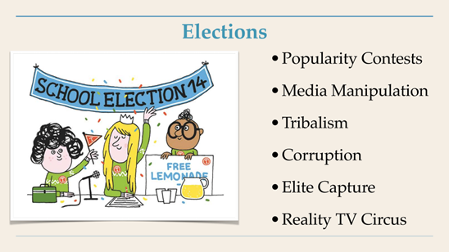

He said the media manipulate elections in many ways – and increasingly the social media are doing that. The electoral system divides us into competing partisan tribes that polarize us into acting like cheerleaders for our tribe and hating the opposing tribe. There is no incentive to find common ground or even to see our political opponents as fellow citizens and human beings. We are told to despise them.

Our electoral process is plagued by corruption, including “dark money” – huge amounts of spending by secret sources – and lobbyists who give huge amounts of money to politicians’ campaigns in order to legally bribe them to do what the lobbyists want. Sometimes elections are stolen outright. Recently he read that Lyndon Johnson stole an election for Texas State Senate in the 1940s. Corruption is brazen.

Also, he said our elections have been captured by elites. A few hundred thousand persons are the main donors for national election campaigns. “This has an outsized effect on our system,” he said.

Especially in the past six years or so, our campaigns have been an unending reality TV circus that have left most of the population exhausted and disillusioned.

Glen said nearly everybody recognize the problems that Nick has listed. We have become terribly saturated with those toxic, cynical abuses.

Before we conducted the interview, Nick had told Glen that many career politicians behave badly while in office.

**These problems make people see that our system is not working and lose trust in government:**

Glen said people say they support “democracy,” but actually the U.S. has a “republic” in which we elect people to make governmental decisions for us. If we had a real democracy, we would be making those decisions ourselves. But instead of real democracy we have a “republic” with a class of politicians. He said this TV interview provides fresh information and insights to help us make the transition from the “republic” to truly profound democracy that would empower real people.

Nick said the problem is that we elect people to our legislative bodies. He said when he was younger he had the fantasy that our legislative bodies met in sacred halls and conducted serious deliberations about the important issues. He fantasized that our legislators carried themselves with great decorum and a profound sense of responsibility for making the wisest possible decisions for guiding our communities and our nation. He showed this image on the screen:

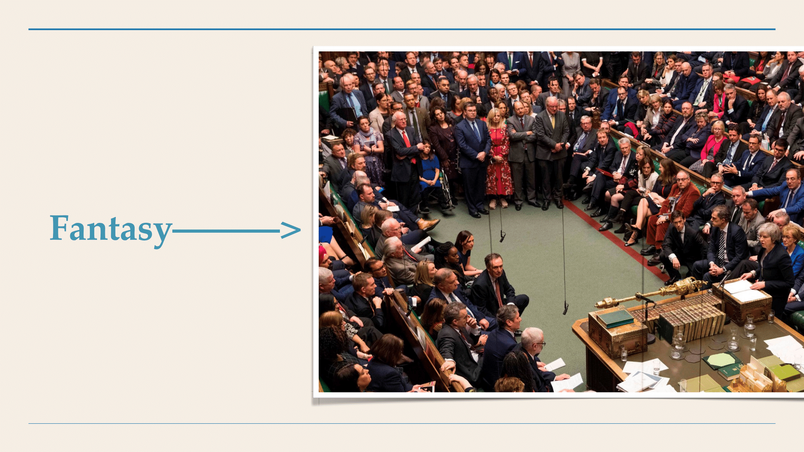

But he said more and more our legislative bodies look more like the next image he showed on the screen:

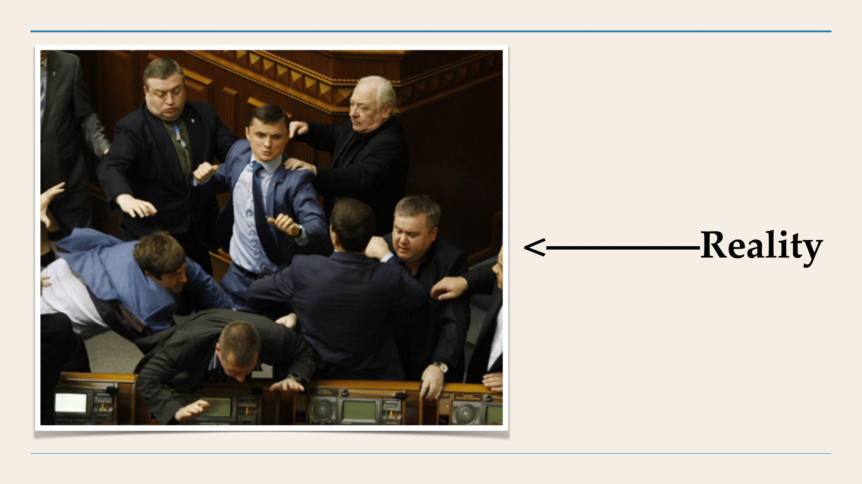

He said politicians behave very badly, fight and sling mud at each other, kowtow to their political parties’ leadership, and vilify the other side. He said they go on media junkets to score points against the other team while boosting their own team’s image and their own personal careers – without much regard for the common good or what’s good for the entire country or the American people.

Glen said that even if they don’t have many actual fist-fights like shown on the screen image above, they are doing that with words and with power-plays and manipulations behind the scenes and behind closed doors. He said the ordinary people are routinely squeezed out of this and don’t have any voice in what’s really going on. It’s a power grab.

Nick said it feels like a game; “they are playing games and the rest of us are getting hurt in the process.”

He showed this image:



He said it seems like two giant teams are always at war. He mentioned the famous quotation from Carl von Clausewitz that war is a continuation of politics by other means. Actually, Nick said, it often seems that politics are war by other means. This leaves us feeling that we are simply shouting at each other from opposing sides with extremists at the opposite ends of the spectrum dominating us with what is mistakenly portrayed as “debate.” He showed this image on the screen:



Partisan opponents are unhinged and not acting in good faith They catch the rest of us in the middle.

Glen said our current system is “name-calling and all that other crap.” He said if we had a real debate about an issue, someone could say, “Here is what I understand, and here are the facts that support my position,” and someone else could do this about their own insights, facts and positions. Then we could discuss the issue rationally and reach a well-informed decision.

Nick agreed and said, “the electoral system does not incentivize finding common ground or even acknowledging that the other side has a good point.” The electoral system is all about polarization and demonization. Social media have made all of this worse, he said.

Nick showed this image on the screen:

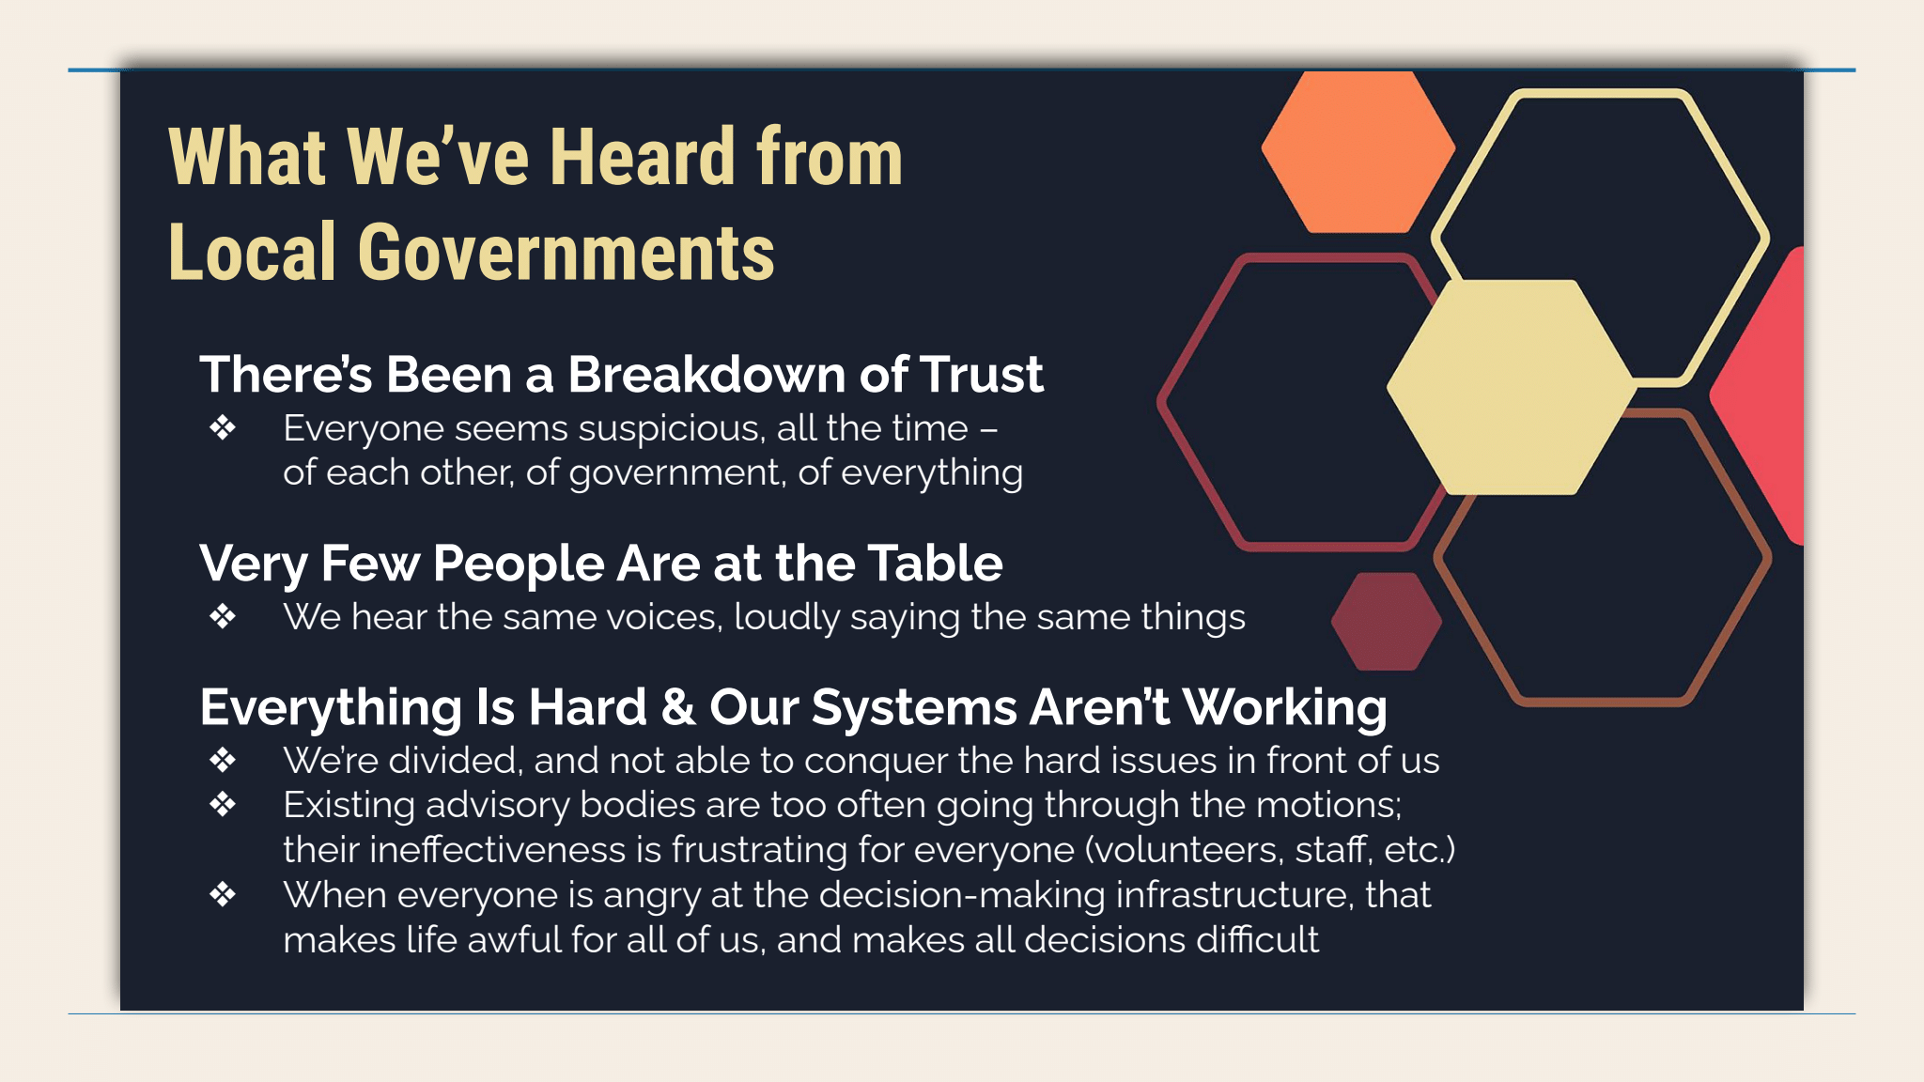

He said the problems we are discussing exist also in local governments. There has been a breakdown of trust. Everyone is suspicious of each other and suspicious of the government. Very few people – the same people over and over again – are at the table. They keep loudly saying the same things over and over again. All of this keeps making things hard and keeps convincing people that our system is not working. We keep not solving difficult problems. Many people end up angry, alienated, or apathetic.

Glen said when politicians say bad things about each other – and when political parties say bad things about each other – we need to recognize that the problem is systemic. It’s this electoral/political/partisan SYSTEM, so it’s not enough to simply replace one politician with another one. We need to change the dysfunctional SYSTEM.

He said we are taping this interview in early May 2023, and he has been seeing new public opinion polls reporting that – looking ahead to the November 2024 election – most Americans do NOT want Trump to be president again, and most Americans do NOT want to re-elect Biden either. Yet – contrary to majority public opinion – both of the big political parties are currently absolutely hell-bent to nominate these two politicians that most Americans do NOT want! The two big political parties are dominating the process and utterly disregarding what the voters want! Clearly, the U.S. has a HORRIBLY DYSFUNCTIONAL SYSTEM dominated by two big political parties that are out-of-touch with the voters! We must examine and change our partisan electoral SYSTEM! Nick showing this image on the screen:

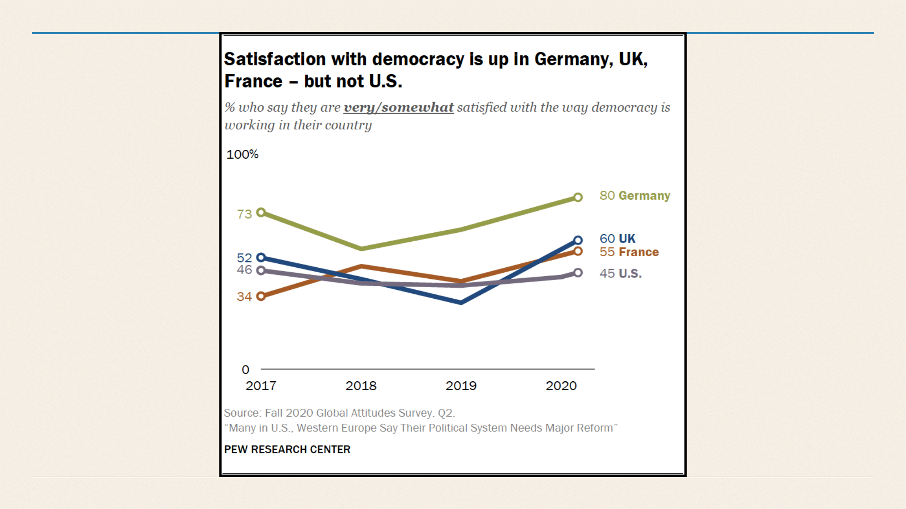

Nick said only 45% of Americans are satisfied with how democracy works here. Germany, the U.K. and France rated higher than the U.S. in satisfaction.

Glen added that the U.S. has a very low rate of voter turnout compared to other nations. In some nations, more than 80% or even 90% of the people vote.

Next Nick showed an image showing big majorities of Americans criticizing how our democracy functions (polarization, rude/disrespectful politicians, lack of public involvement, etc.). Then he showed this image showing 2/3 of Americans (more than in other Western democracies) say most politicians are corrupt:

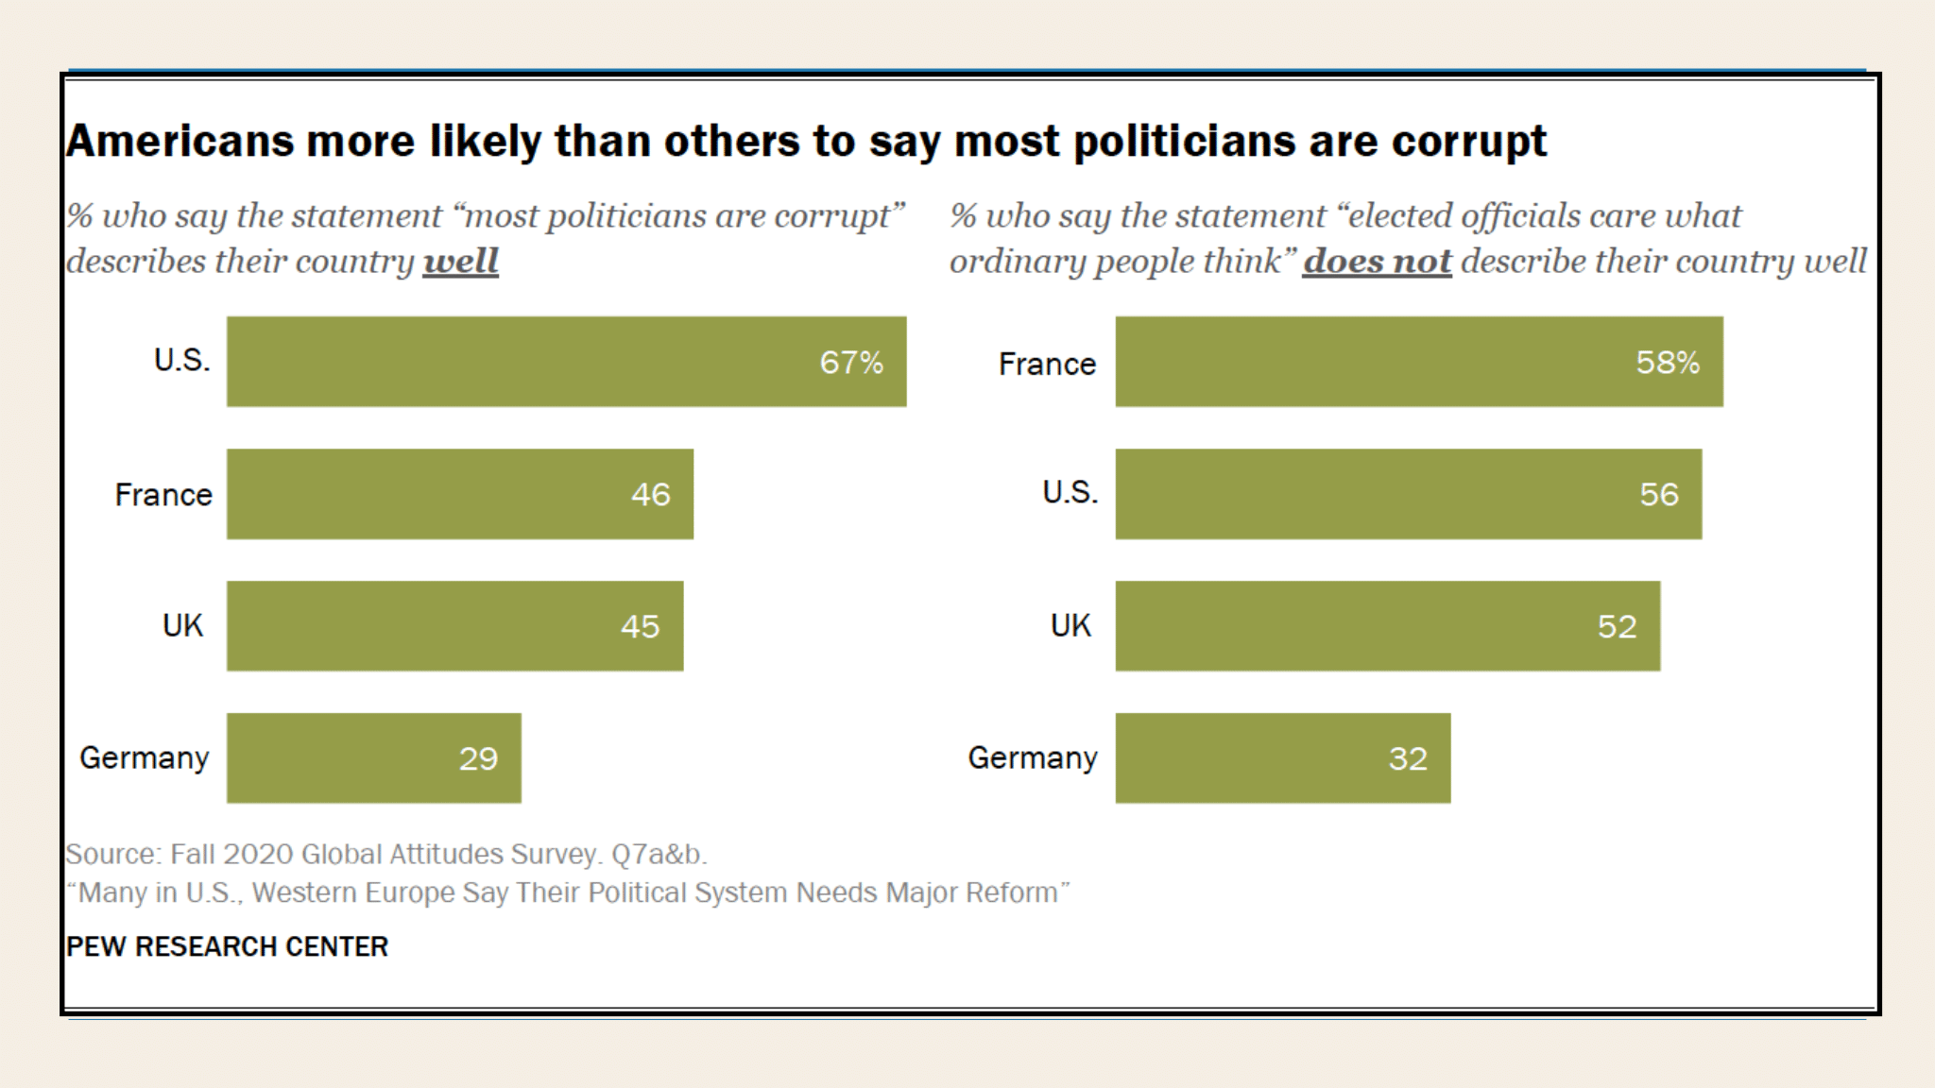

Nick said 44% of Americans think these kinds of problems well get worse in the next few years.

Nick said a core problem in all of this is that we do not see ourselves in our collection of elected officials. Many of us do not look like them. They come from different occupations and class backgrounds and life experiences than everyday Americans do. A big majority of members of Congress are men and white. Many of them are old. Most of them are lawyers or businessmen. Half of the members of Congress are millionaires, and most of the other half are close to being millionaires. “This is profoundly not a representative body” in reflecting the mixt of American people.

Glen agreed. Congress does not include people who were elected to Congress immediately after having worked in an industrial plant or a grocery store checkout line or washing dishes in a restaurant. Those people are not elected to Congress – or even to state legislatures – or even to city councils. Congress members come from the elites, but almost zero of them come from the kinds of jobs that the vast majority of Americans hold.

Nick said nearly all members of college have graduated from college, but only about 35% of American adults have. This education gap is another way in which Congress members’ perspectives are different from the rest of us.

He said we have 40 million poor Americans, but zero poor persons in the halls of power.

He said working class people and everyday Americans look at our representatives and do not see themselves. This causes a profound sense of alienation – a gap between our government and We the People. This increases the sense that the government does not really work for everyday people. It works instead for the tiny 1% or even less of our population.

We did not have time for Glen to provide more information about the many public opinion polls that keep reporting that the American people do NOT trust our government.

The government keeps failing to solve problem because of corruption and other systemic problems. People really do know that the government has hurt ordinary people and our environment in many ways. The government lets big businesses avoid regulations that would protect our environment and our health. People know the government lets big businesses – and extremely rich people – avoid paying their fair share of taxes. The list goes on and on.

These problems are causing many people to lose confidence in democracy itself, so more people are seeking “strong men” autocrats.

**Many reforms have been proposed to fix our electoral system’s problems:**

Glen said many people have been proposing a variety of reforms for our system, and many of those reforms deserve our support. But they do not go far enough to solve the systemic problems in our governmental malfunctioning.

Nick showed this image on the screen and mentioned some of these. He said he has considered all of them, but he sees them as tinkering around the edges while the actual problems are more deep-seated. He researched to find the root of the problem. This led to the solutions he recommended later in our interview.

We did not have time to discuss reforms now during this interview, but some of Glen’s previous and future TV programs discuss them. At the end of this document Glen provides links to TV programs about Ranked-Choice voting and getting big money out of election campaigns.

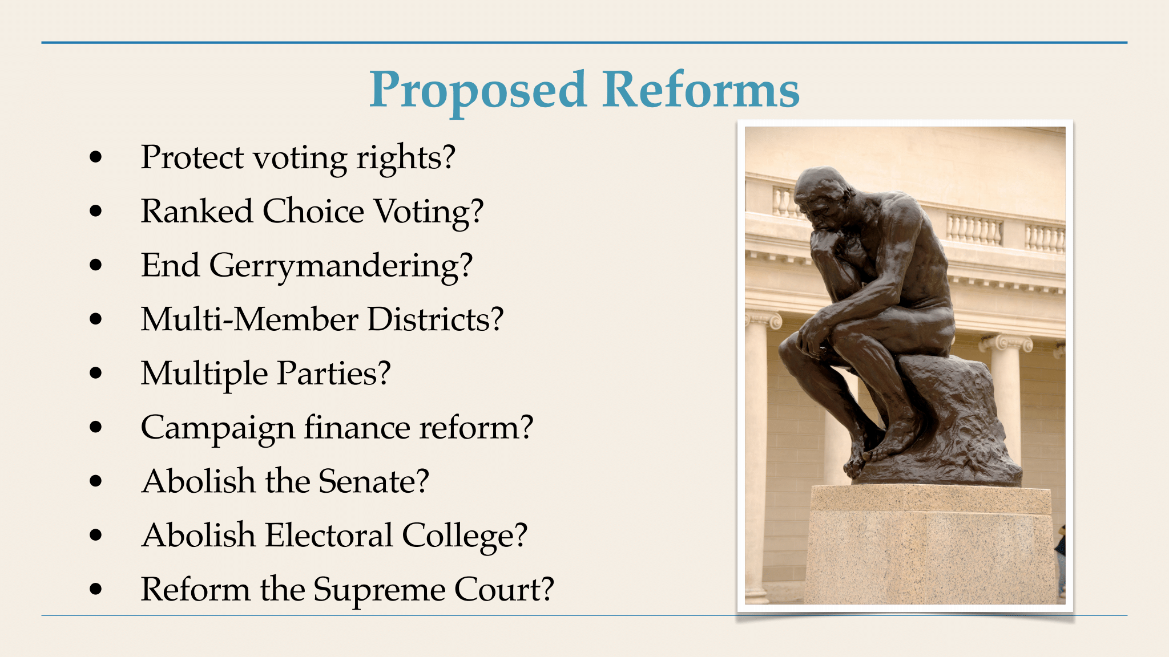

**The democracy in ancient Athens actually was very profound. Let’s learn from them:**

Glen said that nowadays, people look back at ancient Greece, which had a functioning democracy that served the public very well. Nick has studied that thoroughly. He showed some images on the screen and explained how and why ancient Greece’s democracy worked so well.

Josiah Ober, an American historian of ancient Greece and classical political theorist, wrote, “Greece was great because of a cultural accomplishment that was supported by sustained economic growth. That growth was made possible by its democratic approach to politics.”

Nick’s research explained how Greece’s democracy worked and how allowed Greece to flourish and get rich. He shared information that almost no Americans know. Their system was profoundly democratic because – **instead of electing a political elite class to rule over them, they used lotteries to randomly select people for short terms of office.** This lottery process is called ***sortition***. He showed images on the screen and explained how it worked.

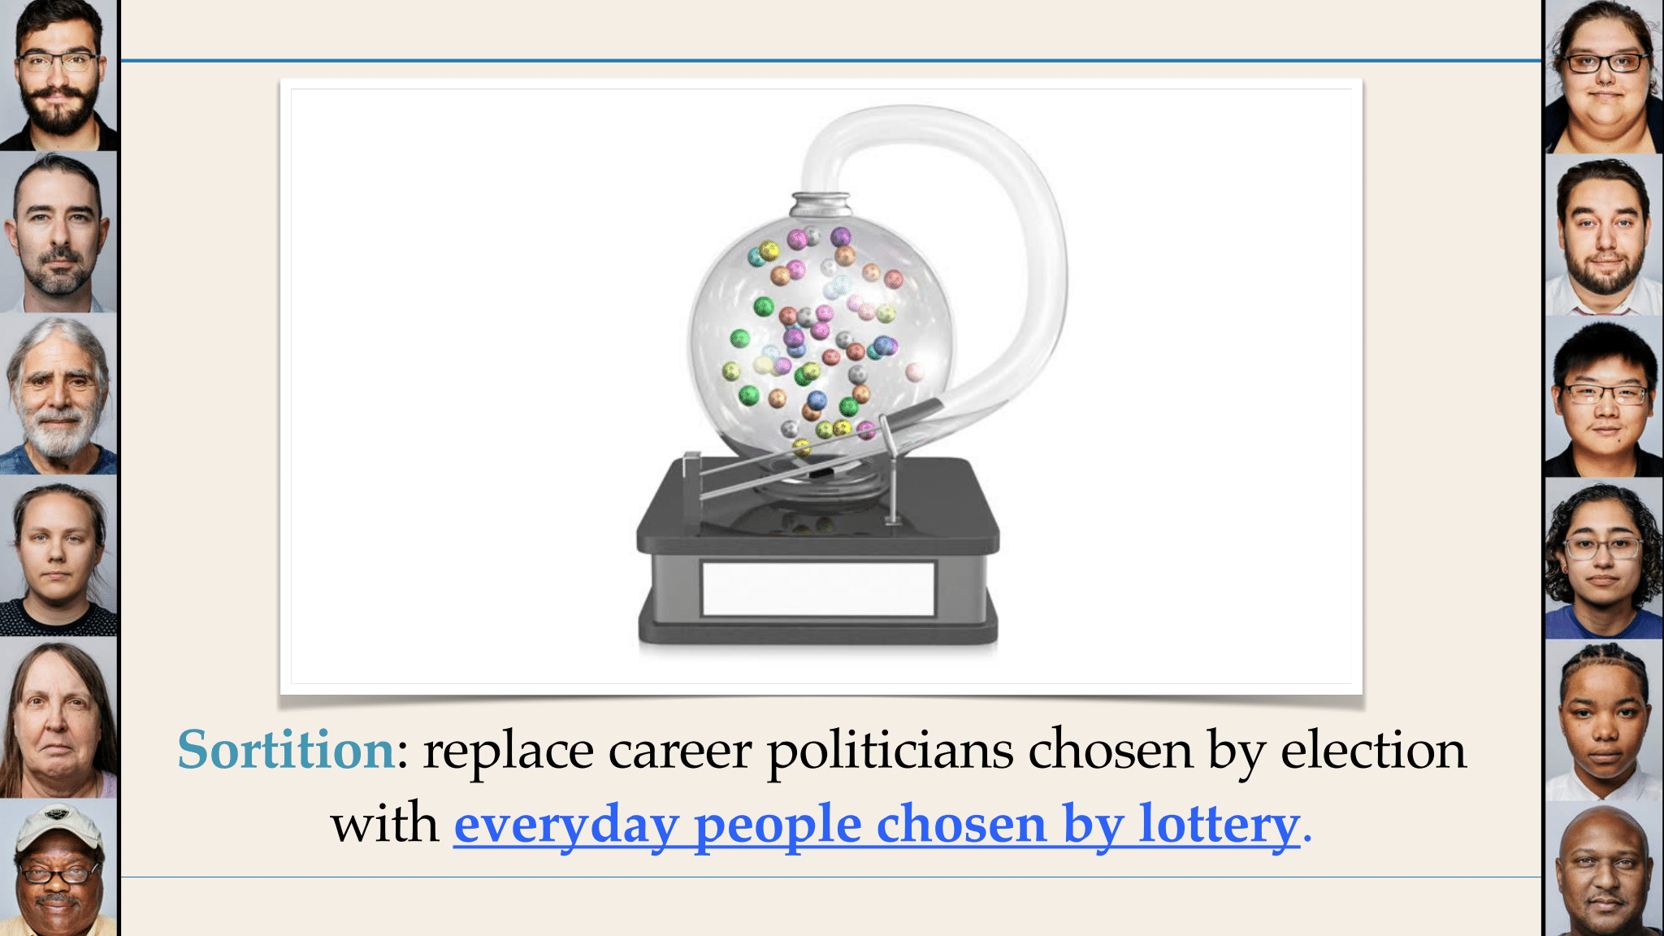

He said this might sound crazy, but this actually was how the greatest democracy of all – in ancient Athens – practiced self-government. Athenian democracy lasted for several centuries (594-322 BCE), but nowadays people don’t know how or why it worked so well.

He said Athens had a very diverse population of about 300,000 to 400,000 people. Some lived in the city, while others lived nearby and some lived on the coast. Before their democracy arose, they had been ruled by a monarch and then by an aristocracy.

They transitioned to a ***democracy***. That word was created by combining two Greek words: ***Demos*** means “people” and ***kratia*** means “power.” See the image at the top of the next column.

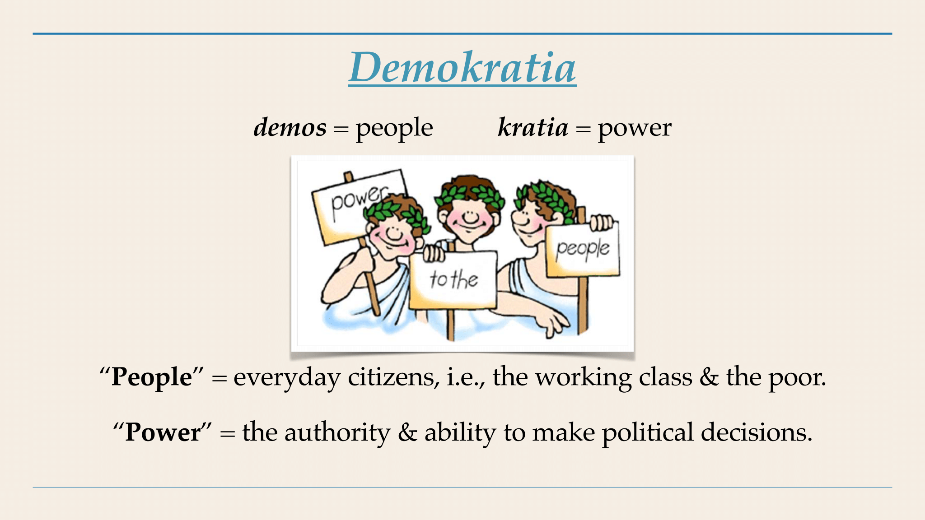

Nick said the Athenians’ concept of “people” really did mean everyday citizens, including the working class and the poor. Their “power” really did mean people’s power to make decisions for themselves. **Their democracy literally meant “people power”!** He also offered what he called “a more robust definition of democracy” and showed this:

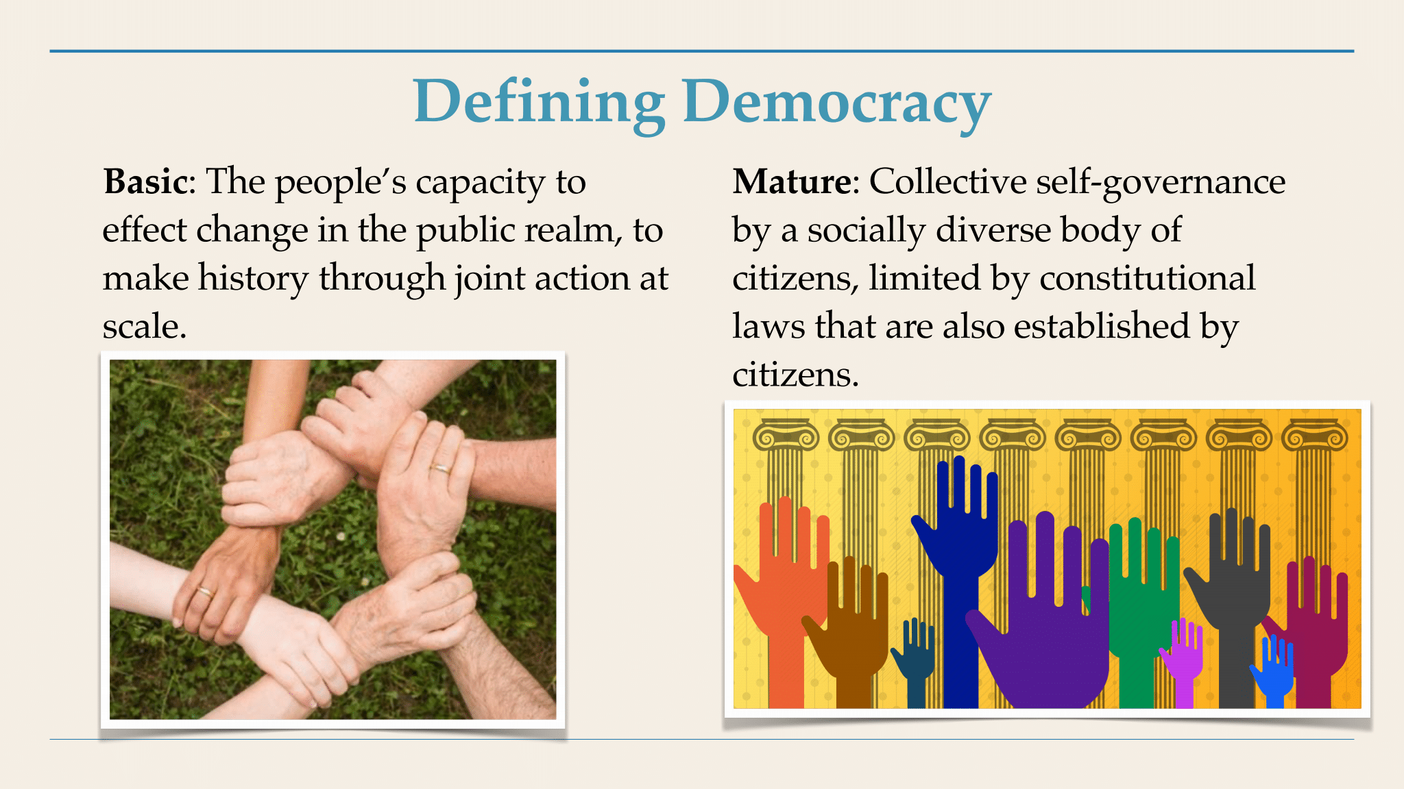

Nick said the Athenians identified three major kinds of governments. (See the image below.) He said ***democracy*** is self-rule by the people themselves. Government by elites could take two forms: an ***aristocracy*** is rule by the so-called “best,” which is similar to ***plutocracy*** (rule by the rich). An ***autocracy*** is tyrannical rule by one person. He showed this:

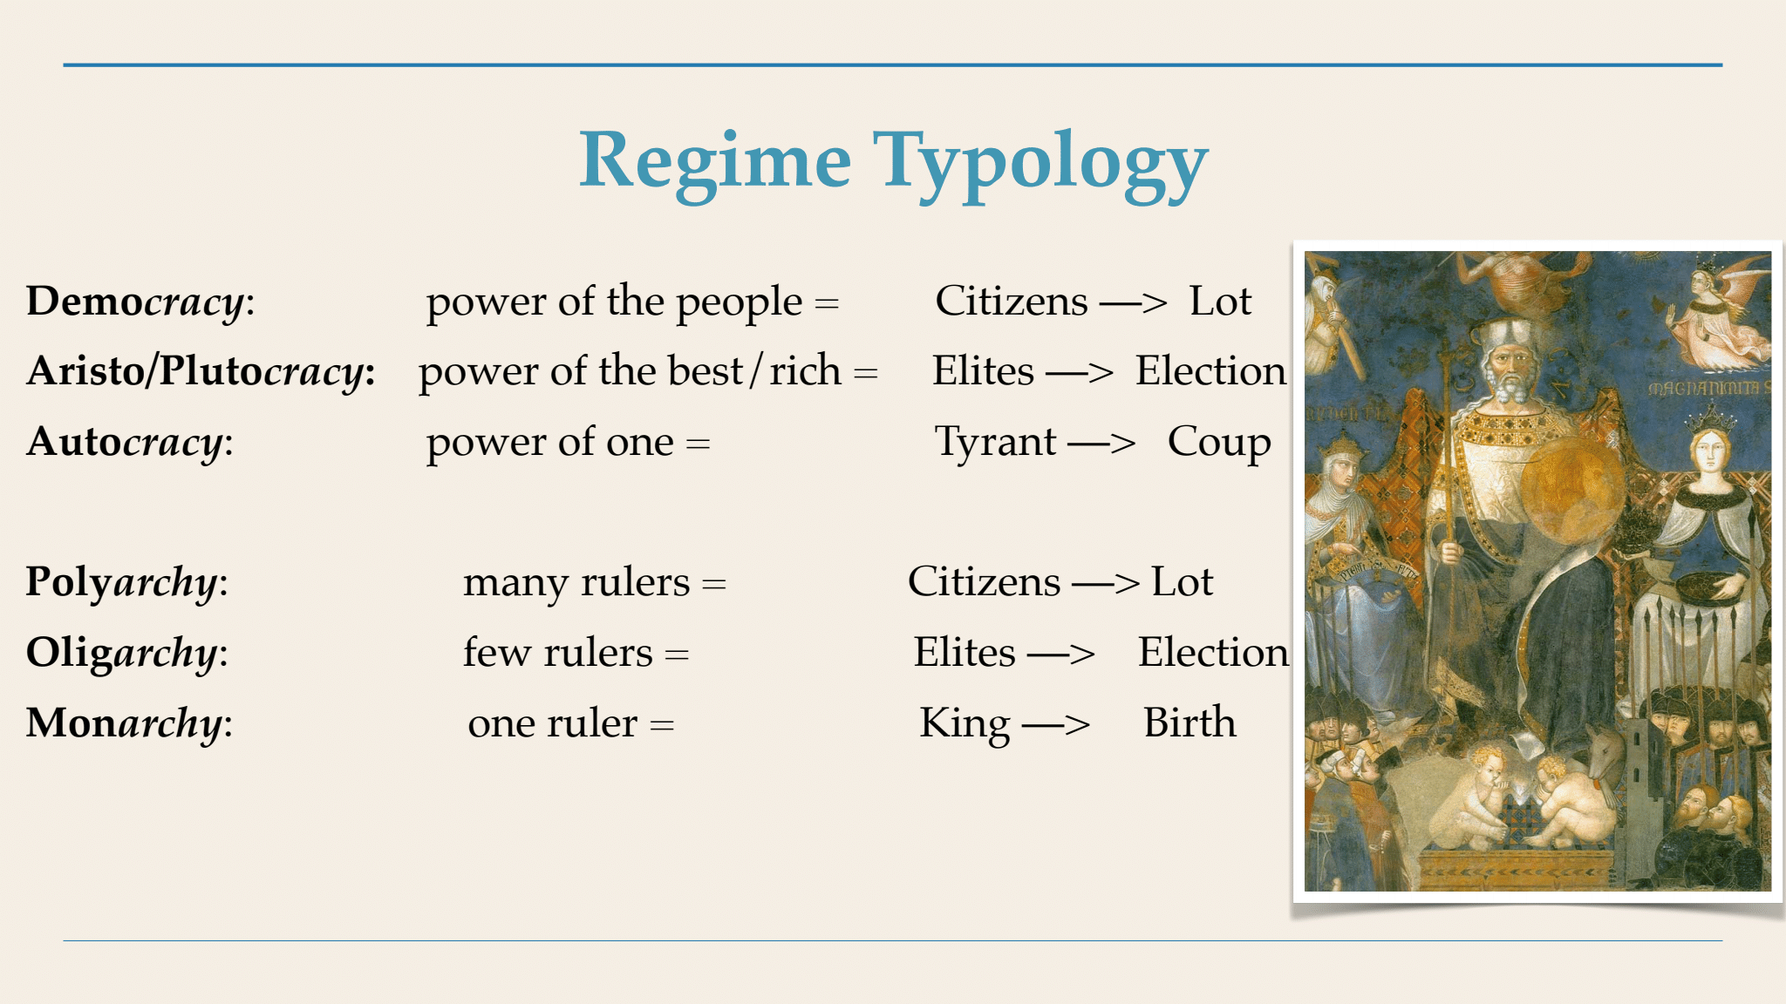

Nick also explained another column on the image in the bottom corner of the previous page, which explains how the rulers of each kind of government are chosen. He said many tyrants take power through coups. Elites (aristocrats and plutocrats) govern after they have won elections. He said Athenians believed elections led to aristocracies and plutocracies, not democracy.

**Athenians believed that if you want a democracy, you should choose rulers by lottery, where any citizens can be chosen at random to be empowered to make governmental decisions**. He said this insight comes as a shock to us, but it really did work, and it allowed a very sophisticated way of practicing self-government. He showed on the screen this diagram of their system, but we did not have time to explain it beyond the very brief summary typed below it:

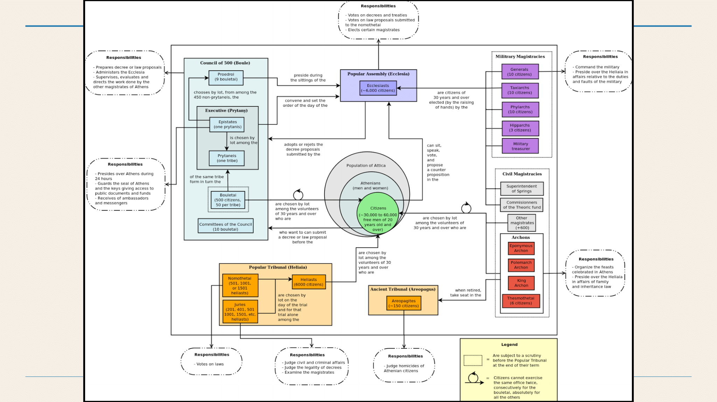

He said the central circles show the people. Free adult males are shown in the small green central circle. The rectangles around the edges were the various kinds of legislative bodies, administrative bodies, and judicial bodies. They had juries for civil, criminal, and legislative functions. They also had a council of 500, which also assured broad-based democracy.

He said for nearly all of these positions – performing legislative, executive and judicial functions – **people were chosen at random by lottery to fill those roles**. Only a very, very few governmental roles (*e.g*., military generals) were chosen by election. All other roles were chosen by lotteries.

Their system required mandatory rotation, very short terms of office (usually a year or less – and some jury members served for only one day), and limits on how many times any individual could serve. For nearly all positions, an individual could serve only once in their lifetimes, but for a few positions a person could serve twice in a lifetime, but not consecutively.

**He said Athens’ democracy produced a high amount of public participation in their government.** Over a period of 30 years, one-fourth or one-third of the population would serve for a year on the all-important Council of 500 or serve for a month on the Council’s executive board. Nearly 70% of the people would serve at least once in their lifetimes on that Council. An overwhelming number of people participated also in any of the many kinds of juries and the many magistrate roles. Some people could truthfully say, “I was president of Athens for a day,” because the presidency rotated every day.

Athenians believed that democracy works when people take turns ruling and being ruled. He showed this image of a sophisticated machine they built to select people at random for the all of their governmental positions. The machine would sort people at random for their short-term duties:

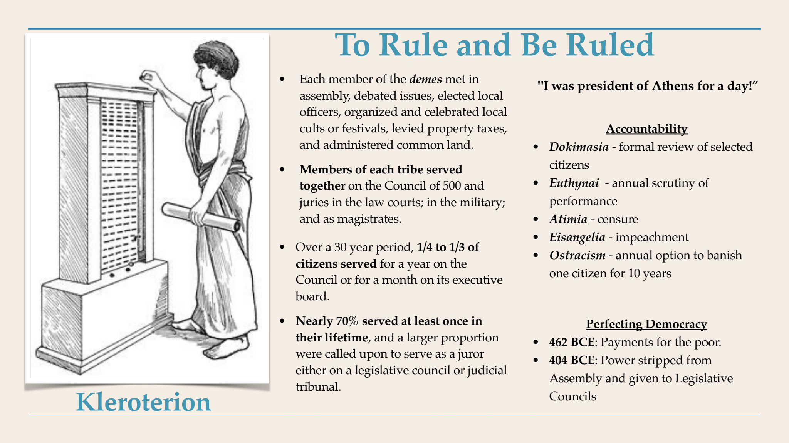

Athens’ government included many safeguards, including scrutiny of performance, impeachment, and even stripping someone of their citizenship if they seriously abused their office.

They also kept improving it in various ways. The lower right corner of the image above says that in 462 BCE they started making payments to poor people who were serving in democratic positions. Also, in 404 BCE they transferred some power from the Assembly and gave it to Legislative Councils (legislative juries).

Aristotle lived during this era, experienced the democracy first-hand, and wrote about democracy in his famous text, ***Politics***. Aristotle said explicitly that if you want democracy, use lotteries, because elections cause oligarchies (governments by a tiny number of elites):

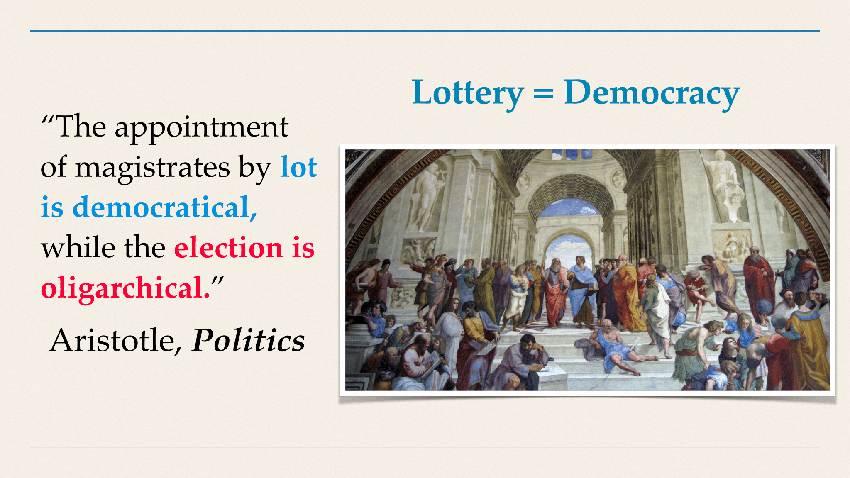

Nick said their profound democracy led to the flourishing of Greek society and all of its many excellent achievements in philosophy, science, the arts, mathematics, culture, etc.

Nick said the quotation in the right column came from Stanford University’s professor Josiah Ober, an expert on ancient Athens:

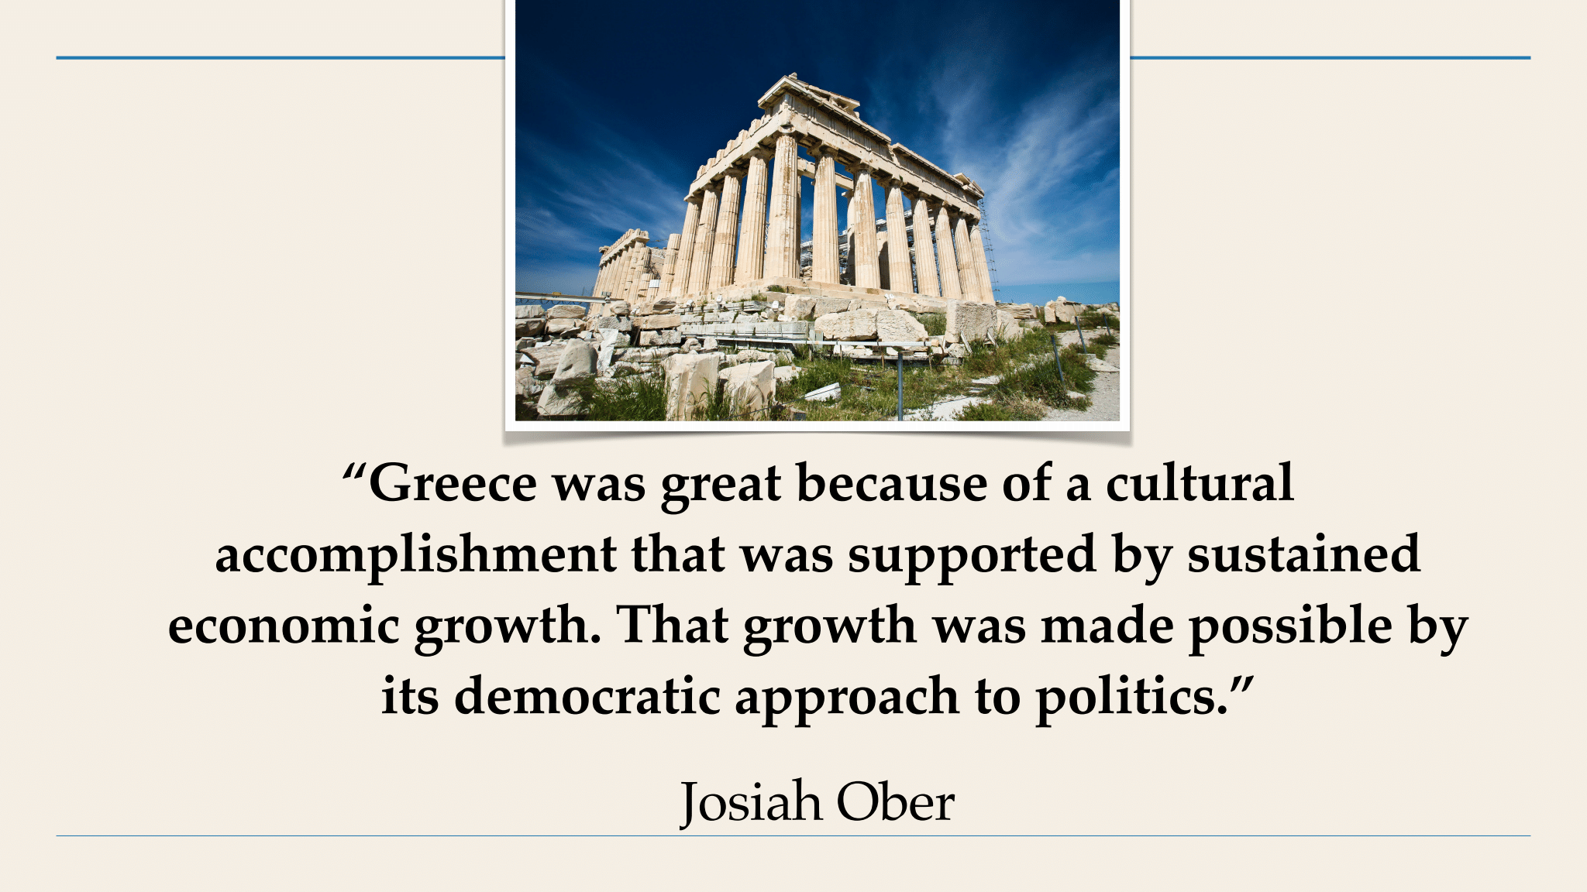

**The U.S. was founded by rich men who distrusted ordinary people and wanted a republic   
instead of a profound democracy, so they wrote our Constitution to restrict the general public:**

Next, Nick discussed the quality of democracy in the United States. He said we do have some history of face-to-face democracy from First Nations, such as the Iroquois Confederacy and the American colonial era and New England town meetings. But the U.S. Constitution and our current form of government are seriously deficient.

Our history’s Revolutionary era included a radical element, especially in the writings of Thomas Paine, who wanted a more robust democracy.

But, Nick said, people now will be shocked to learn that when the Constitution was being written in 1787, the framers did not want democracy. He said they actually despised democracy. The Constitution was written by 55 aristocrats:

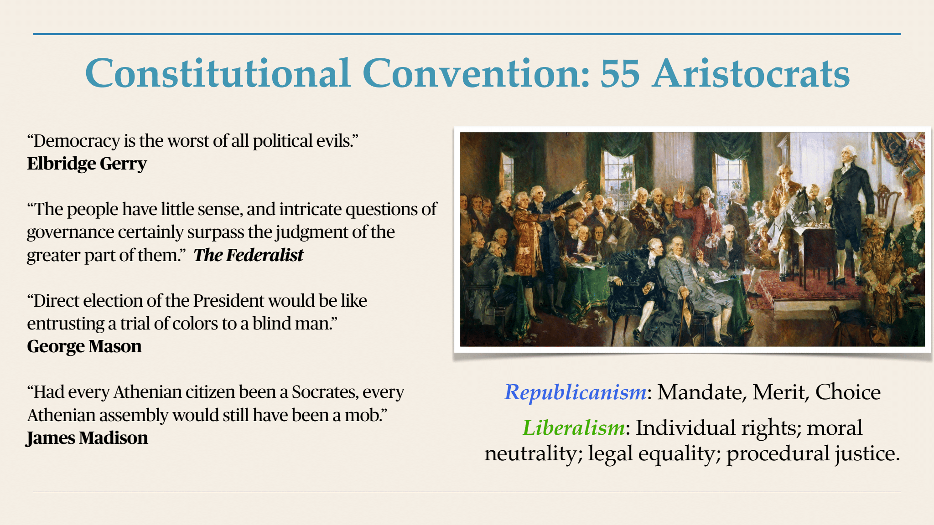

He showed the image above, quoting several of our founders. He said they thought democracy was evil, people were not capable of self-government, and Athenian democracy was mob rule by the majority.

Instead, our founders used Rome’s republic – with elections – as their model. He showed on the screen this list of anti-democratic features of the U.S. Constitution, which many historians and scholars have noticed:

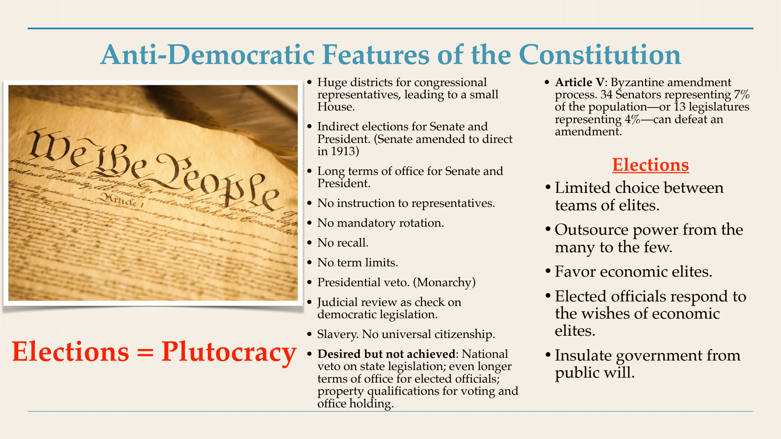

Anti-democratic features include a small number of representatives, long terms of office, presidential veto (which, he said, is a vestige of monarchy), judicial review (which can be seen as judicial despotism), and many parts of the system in which the will of the majority gets choked and stopped by the influences of rich, property-owning elites.

He said the root of this is using elections – a very limited choice of a few competing teams of elites. Elections force us to outsource our power to elites. Elected officials are much more responsive to the economic elites than to everyday citizens. He added that all of this was done on purpose. Madison and the other framers “wanted to insulate the government from the will of everyday people. They wanted a plutocracy, and that’s why they gave us elections.”

Glen said that a few years ago he read a lot about our nation’s founding and the writing of our Constitution. He found that our nation’s founders were alarmed that political parties were developing in Europe, and they strongly opposed allowing political parties to develop in the new U.S. Our founders called them “factions” and saw them as self-serving and polarizing rather than serving the broad public interest. However, soon after our government was created, political parties (“factions”) did arise, and we have been abused and factionalized ever since. Parties have promoted elitism and opposed real democratic participation.

Glen said he is downtown often and sometimes talks with people who are homeless. He said every year Congress passes a budget that refuses to end poverty but instead lavishly funds the military – partly because military weapons manufacturers lavishly fund congressional campaigns. He said the U.S. includes many, many homeless people. If those homeless people donated millions and millions of dollars to candidates for Congress, then Congress would decide to serve their new donors and end poverty. But – because homeless people do not bribe Congress with campaign contributions – Congress refuses to help them, and Congress makes poverty and homelessness to persist. This is just one example of how broken and dysfunctional our electoral system is.

Nick agreed. He also said that our Constitution makes it very, very hard to solve these problems. He said the Constitution’s Article V has a very awkward and difficult way to amend the Constitution. He said it’s harder to amend the Constitution of the U.S. than to amend the constitution of any other nation in the world. Nowadays 34 Senators representing 7% of the population – or 13 state legislatures representing 4% of the population – can defeat a constitutional amendment. He said more than 10,000 constitutional amendments have been proposed throughout U.S. history after the Bill of Rights, but only 17 have been adopted. The most recent one (the 27th Amendment) addressed a small matter and was proposed in 1789 but not ratified until 7, 1992. No others have been ratified since 1971 – more than half a century ago.

Nick said Americans are supposed to celebrate the fact that our Constitution is so old. But he asked whether we would celebrate if our dentistry was the same as it was in the 1780s. He said probably most people would want dentistry and other health care practices to be modern now – updated from what was done 250 years ago.

Glen added that the U.S. keeps refusing to allow women to have constitutional rights equal to men our nation. The U.S. has persistently failed to add the Equal Rights Amendment to the Constitution, despite a century of efforts. He has been paying attention to this since the 1970s, but the nation still fails to constitutionally protect women’s equality. The U.S. government’s failure to add the ERA to our Constitution shames our nation in the eyes of the world and violates our pretense that our nation promotes fairness and equality.

Nick added that our original Constitution excluded many people from citizenship: Native Americans, African Americans, and some others, along with women.

**The general public in the U.S. and elsewhere want major changes and a stronger democracy:**

Glen said the interview now is pivoting toward solutions.

He said people everywhere seem to share a universal human need to be free and independent. This includes self-government.

But in various countries – including the U.S. – people are held back from self-government, so they feel frustrated. Nick showed some images on the screen and helped us understand people’s feelings about this.

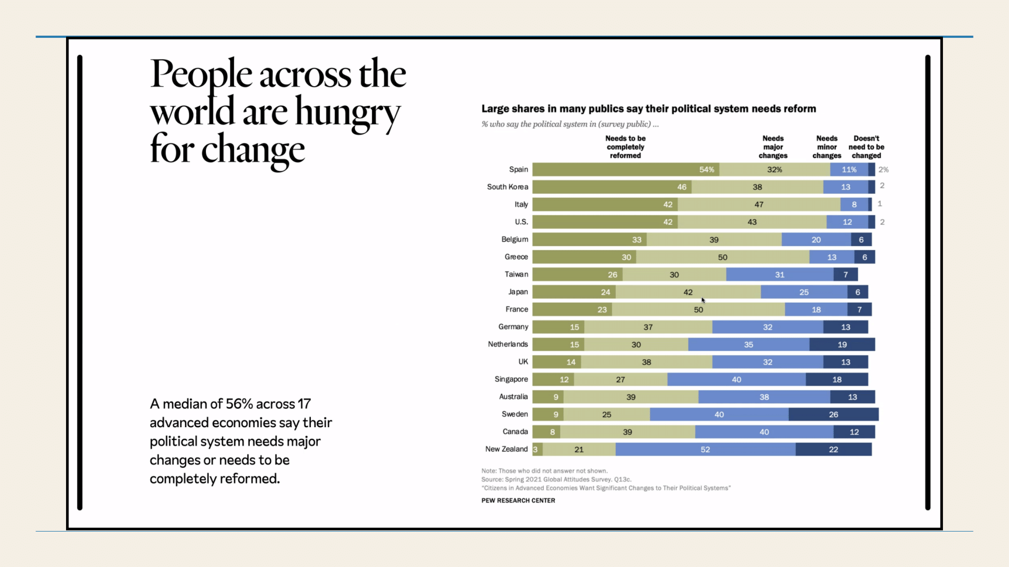

Nick said that people in the U.S. are more likely than people in nearly all of these 17 advanced countries to say that our political system needs major changes (43%) or needs to be completely reformed (42%). He said many of the countries listed here are liberal Western governments, and some of them also have populations that are dissatisfied. Only a few of these nations have majorities saying they need either minor changes or no changes.

He said Americans are hungry for change, so the question needs to be what changes we should make.

We did not have time for Glen to say that he believes democracy is intrinsically best for human beings, because only through democracy can we freely exercise our innate capacities and flourish. Democracy makes us happy!

**Go on to the next page.**

**Two bold solutions: Use lotteries and Citizens’ Assemblies to make governmental decisions:**

Now – having built a foundation of solid information about the problems – we can start exploring bold ways to practice truly profound democracy – from the grassroots up. Nick explained **replacing elections with lotteries** and **using Citizens’ Assemblies** to make governmental decisions.

Glen said that several years ago he heard someone in Seattle urge replacing local elections with “sortition,” the technical term for using lotteries to choose random people to make governmental decisions – and to use Citizens’ Assemblies for this purpose too. Now he is happy that Nick can propose these solutions to our TV viewing audience.

Nick said that Citizens’ Assemblies are a bold new approach to democracy, and it is sweeping the world. He said it actually draws upon the Athenian model and applies it to our time and our place.

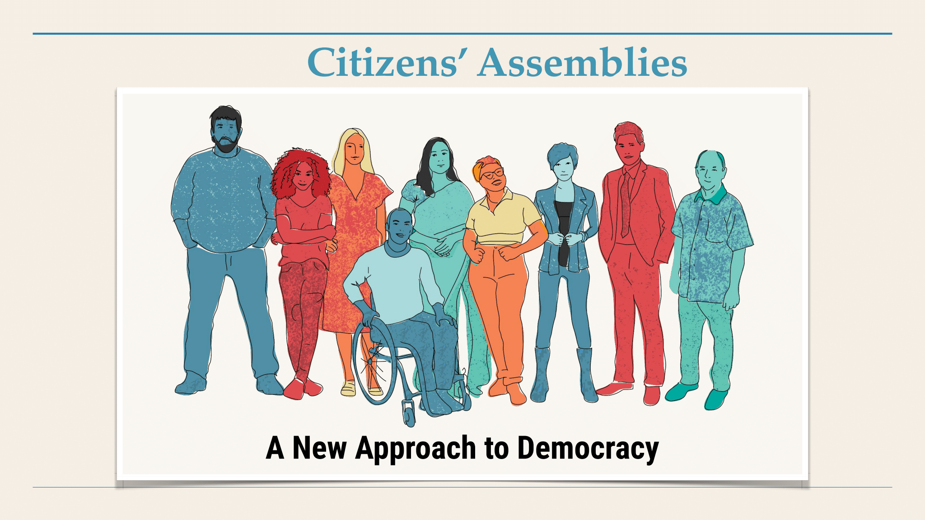

Everyone will participate in in-depth policy-making:

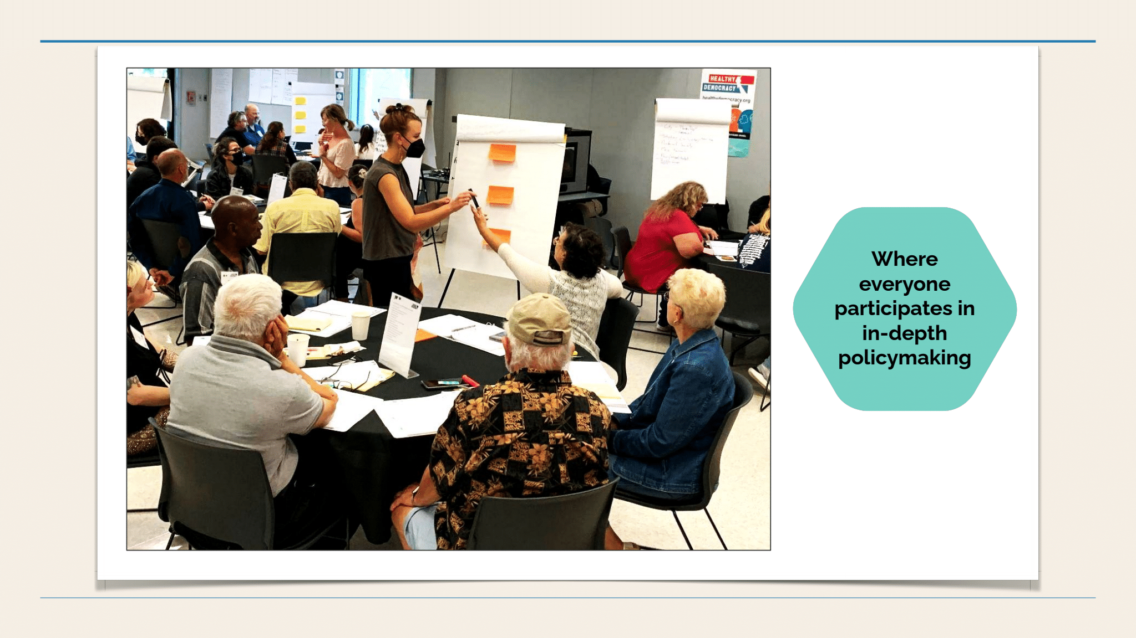

Using lotteries to select people at random makes sense. It’s not a weird concept. This is how we select juries for trials. When our court system needs juries, they select people at random. This produces juries that are diverse in various ways. The intention is to give each defendant “a jury of their peers.” Let’s apply this egalitarian principle more widely to lead to governmental decisions.

Expertise will be both valued and questioned:

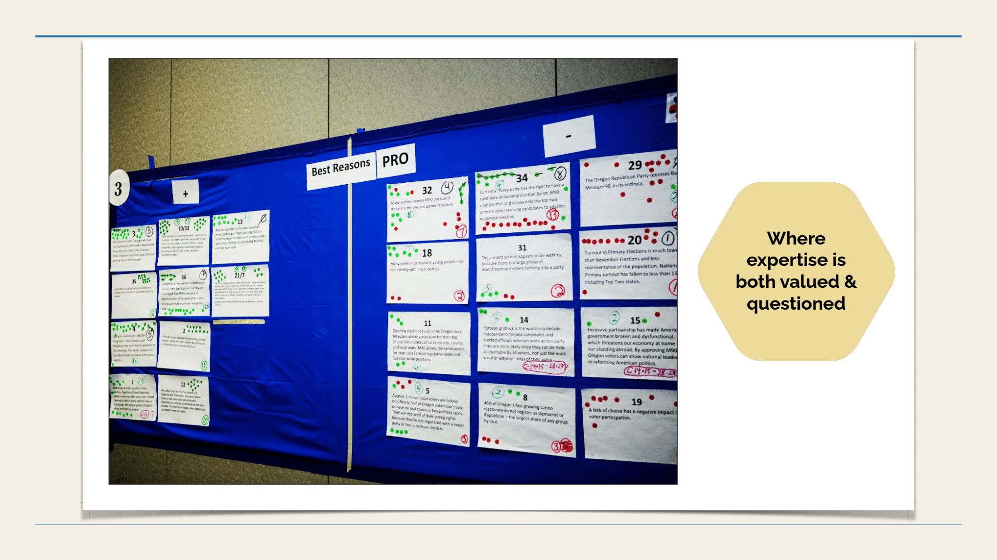

Government will be a tool that we all use together:

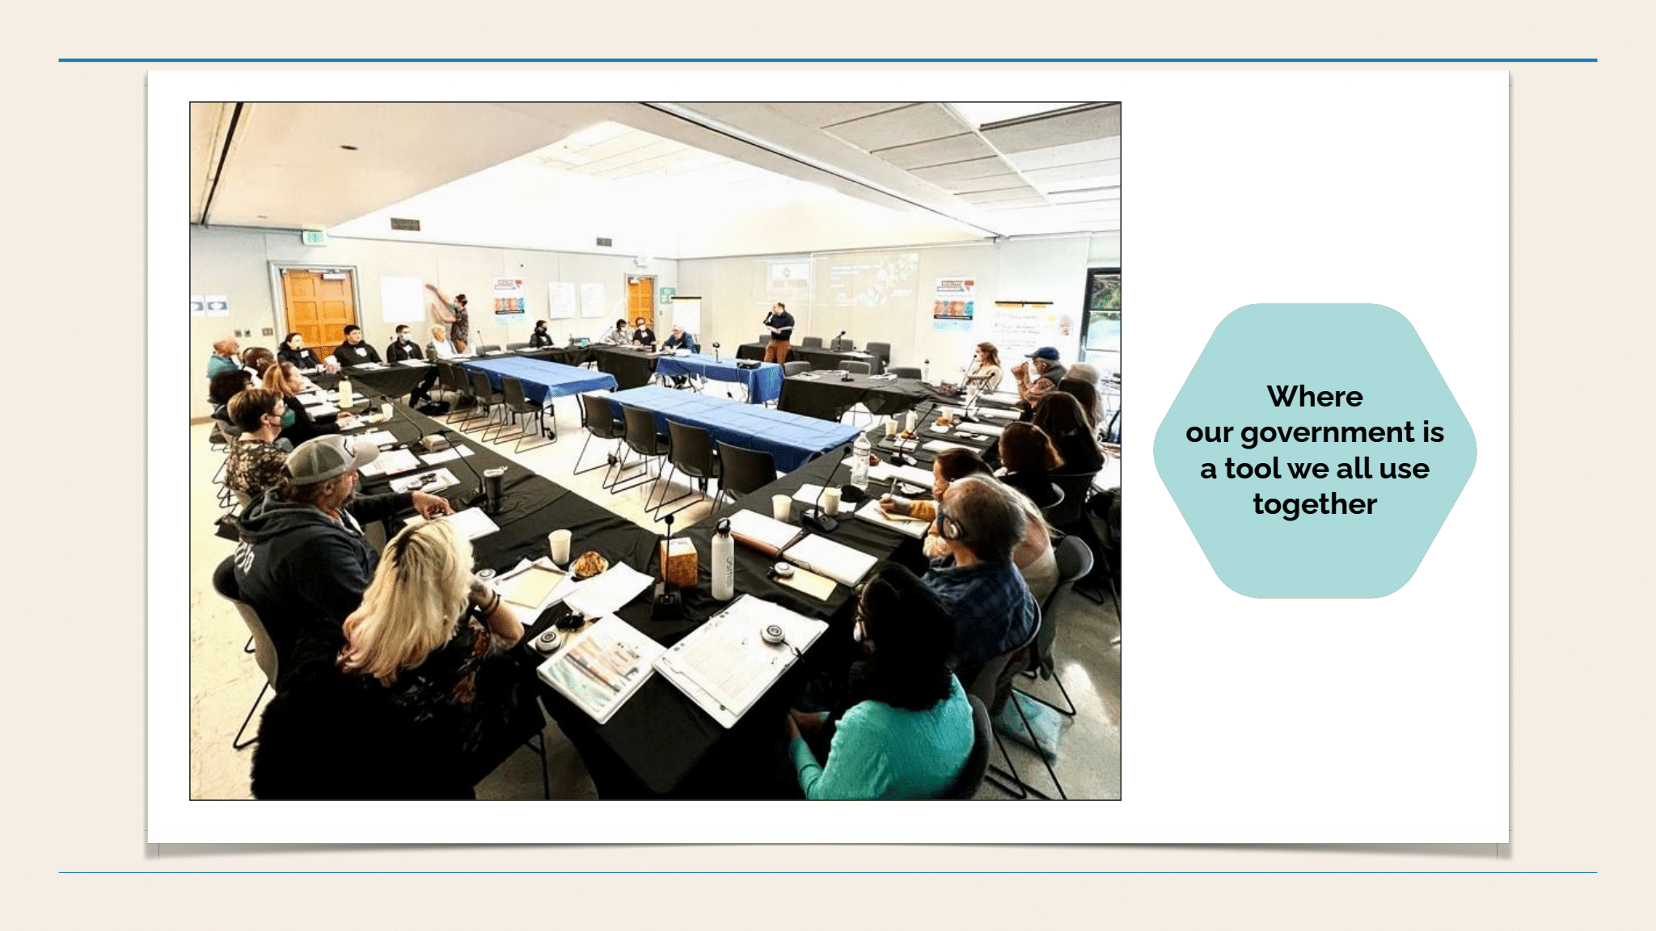

Nick said two main parts of this new method are democratic lotteries and in-depth deliberation:

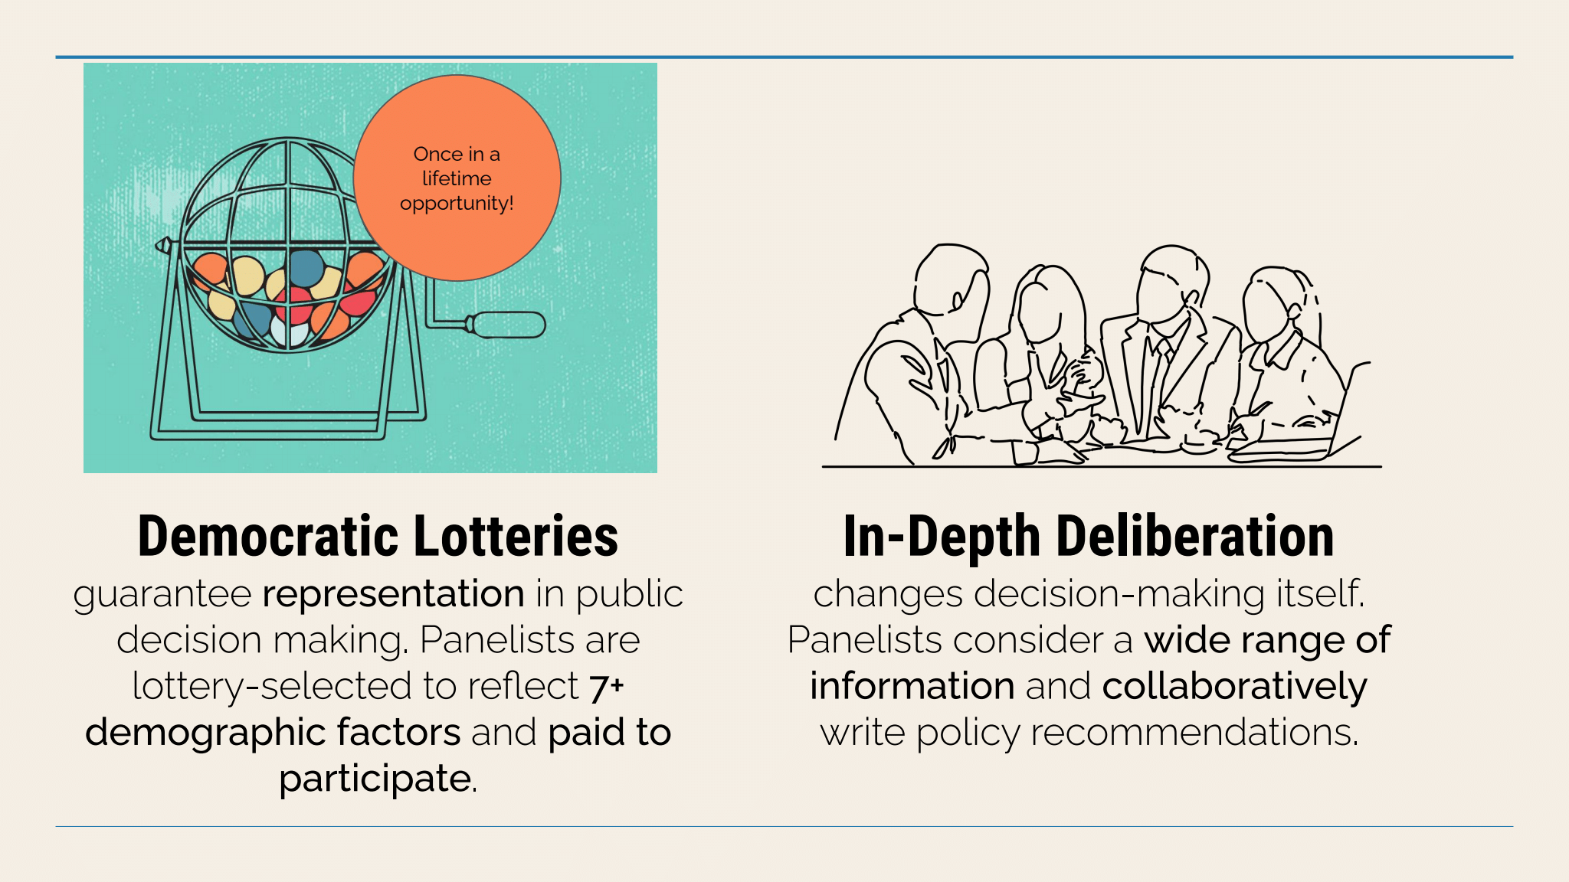

He said that everyday people from all walks of life are selected at random through democratic lotteries to form an assembly with the diversity that exists within the community, so the assembly will truly represent the broad public. They could be compensated for their time.

When they convene into Citizens’ Assemblies, they will engage in very rigorous and thorough deliberation. They can learn from panels of experts providing information from a wide range of perspectives about the issues they’ll be making decisions about. They will work together to write policy proposals.

Nick provided more information about the two steps: the lottery and the Citizens’ Assemblies. He said the lottery step includes (1) an invitation mailer to create a pool of potential panelists – selected at random – who probably had never participated before; and (2) an effort to include demographic diversity (age, race/ethnicity, income level, education, gender, etc.), so the panel’s diversity will match the diversity of the community; and (3) a method of random selection to represent the diversity:

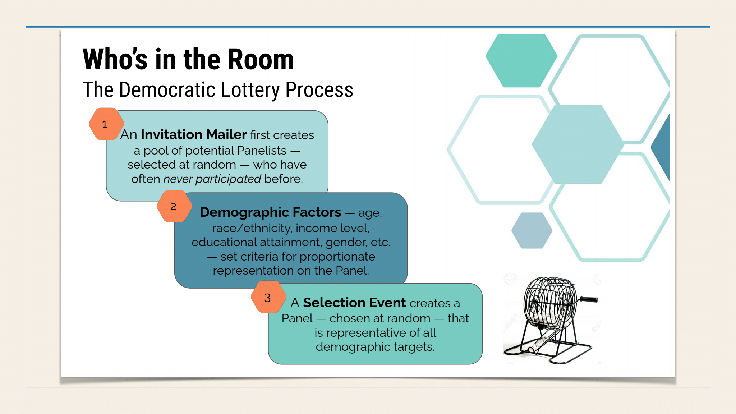

When the panel has been created, they conduct their deliberation in a well-organized way: (1) They will hear from diverse experts and stakeholders. (2) They will deliberate extensively and wisely – with help from trained facilitators who will help them listen to each other and collaborate well to find common ground. (3) They will use their own words to write reports with policy recommendations and deliver these to the decision-makers. Feedback loops are possible too. He said the process values reaching consensus and planning for the long term:

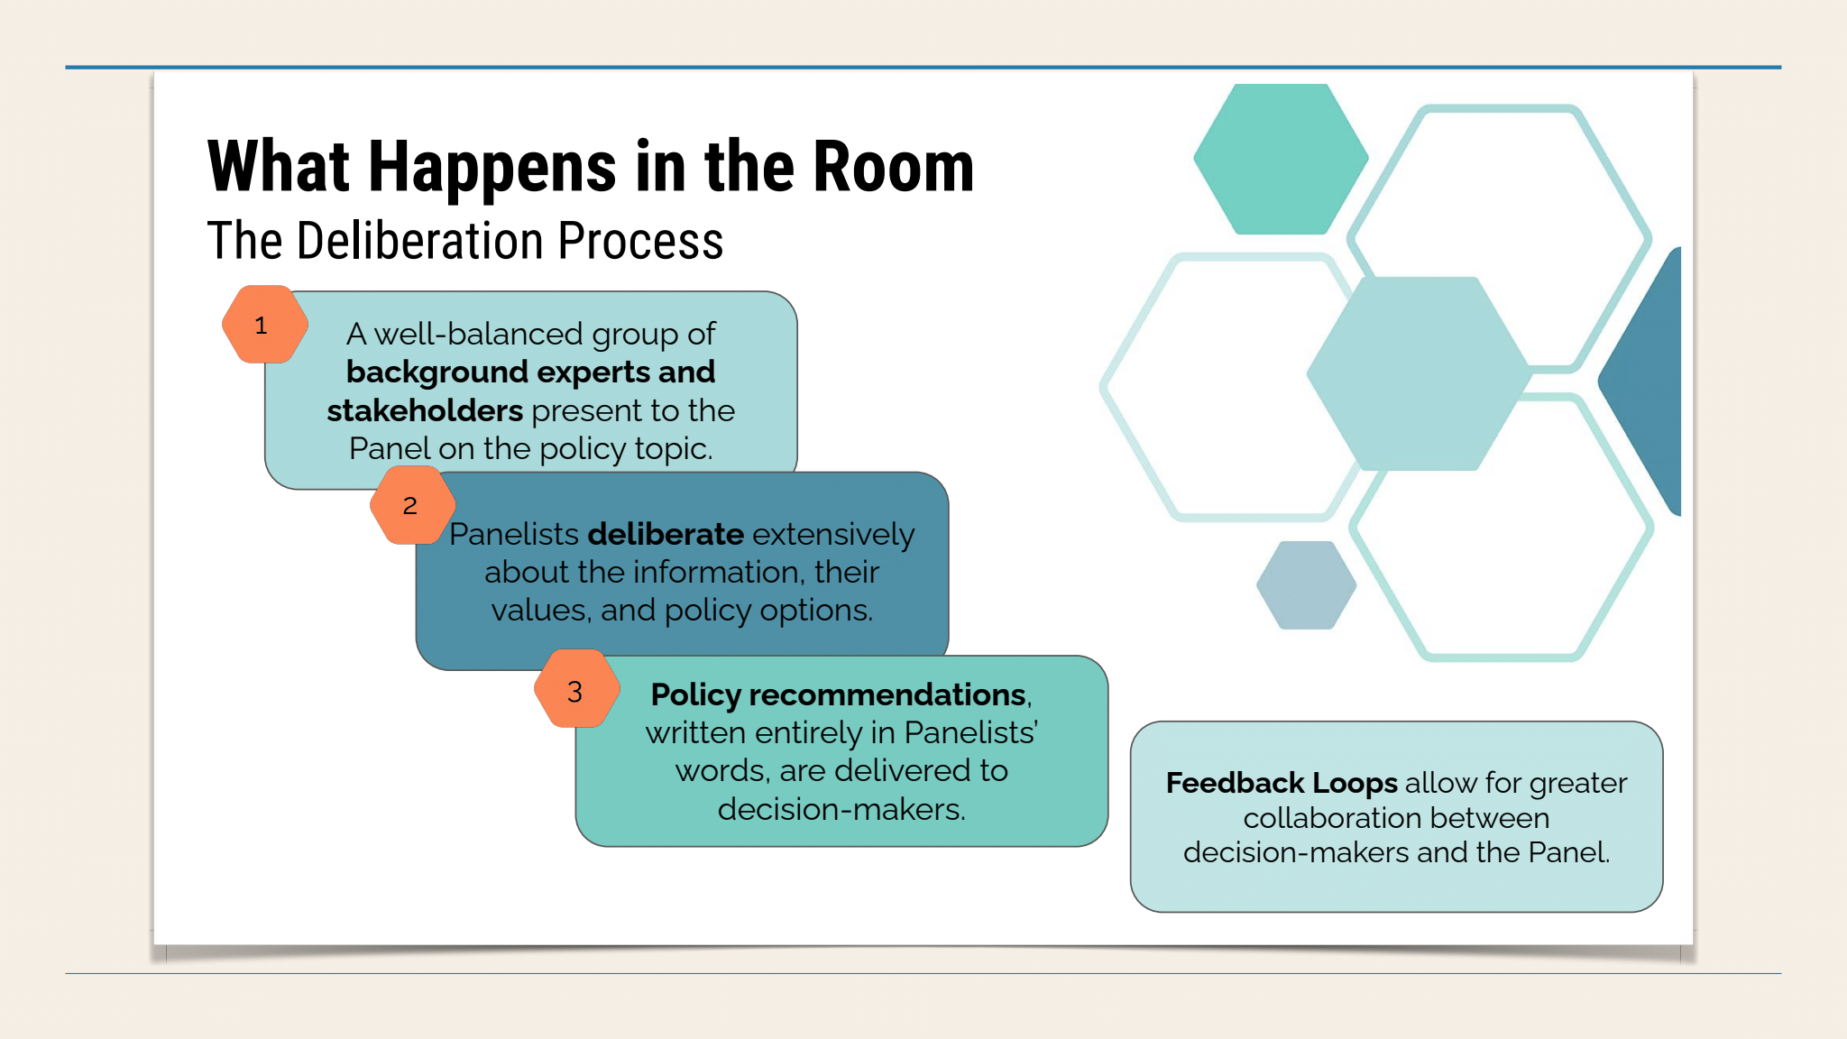

He said the process is based on a number of good principles, including inclusivity, diversity, representation (including demographics, viewpoints, cognitive diversity, etc.), so we can make very wise decisions. Another principle is integrity, which includes transparency and good research. The collaborative process needs to be civil, respectful, and based on valid facts. The process needs to truly empower people and help them understand and practice meaningful power to influence public policies.

He identified some truly significant benefits of these Citizens’ Assemblies. By allowing real people to shape public policy decisions, it increases people’s trust in government. It brings more diverse people into decision-making roles and broadens the diversity of people making public policy decisions. It relies on facts and evidence instead of corrupt influences. It promotes cooperation in political matters. It brings out good ideas that had not been considered before. Nick said when you bring ordinary, diverse people together and use a good process that taps into the community’s wisdom and relies upon valid evidence, they will produce more intelligent solutions to serve our long-term future than what career politicians have been doing.

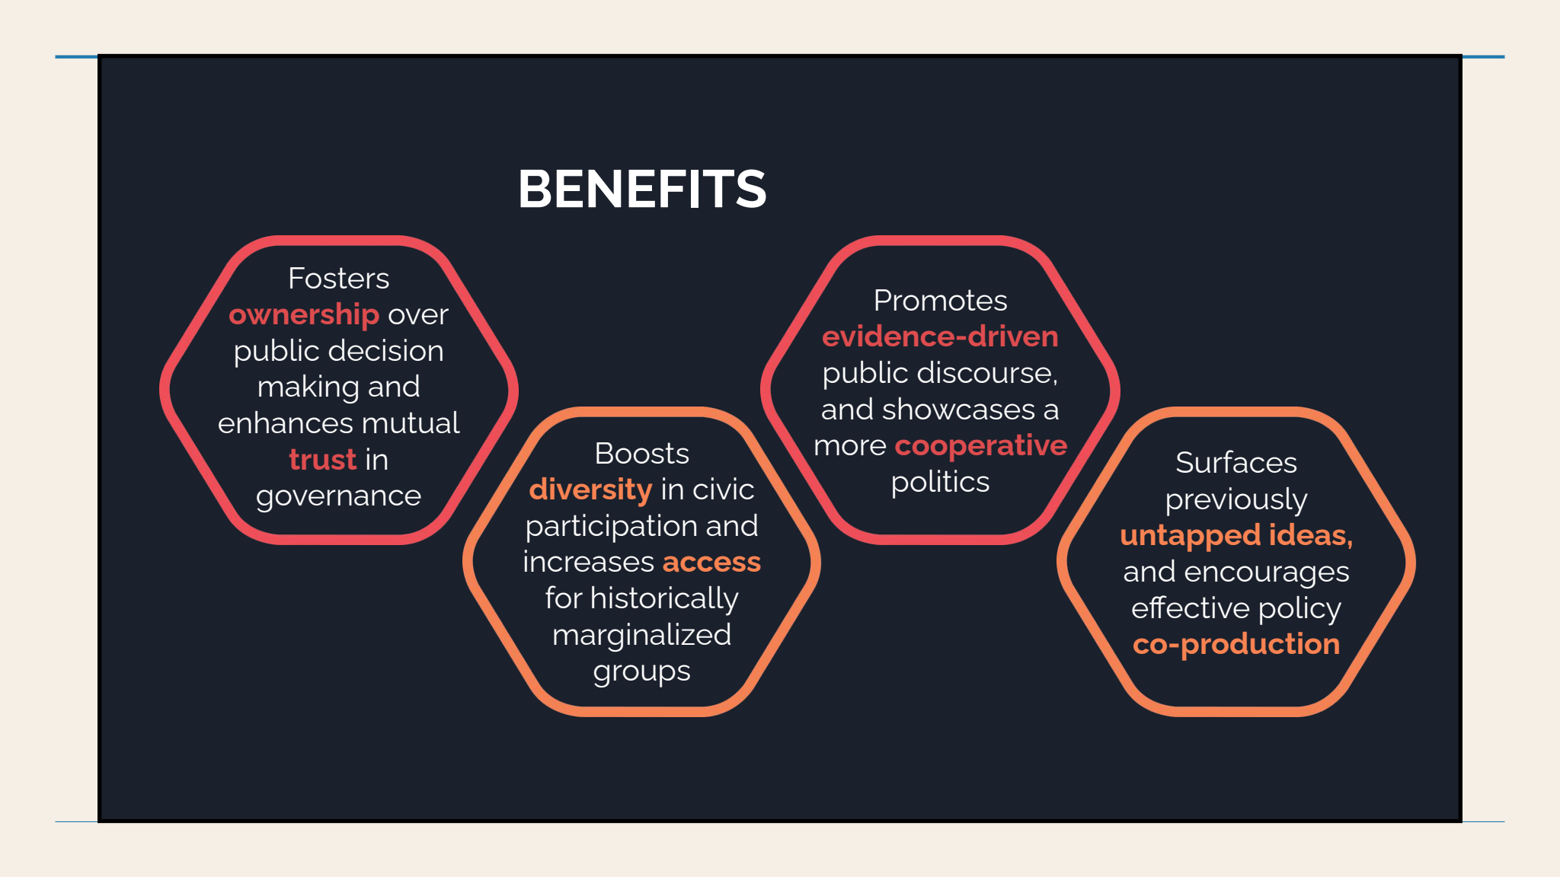

Nick said Citizens’ Assemblies have been increasing worldwide for the past few decades. He said since British Columbia, Canada started using them in 2004, there has been a wave of increasing use:

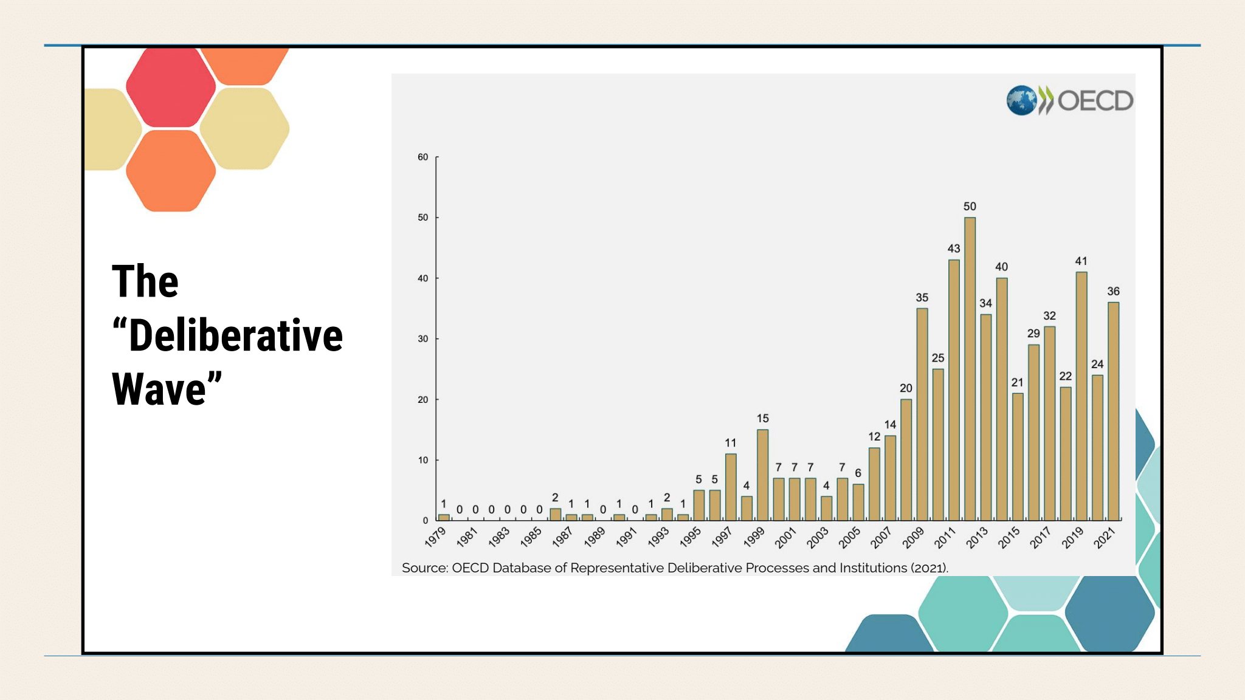

He also showed a world map with red dots showing where democracy by lottery has been used:

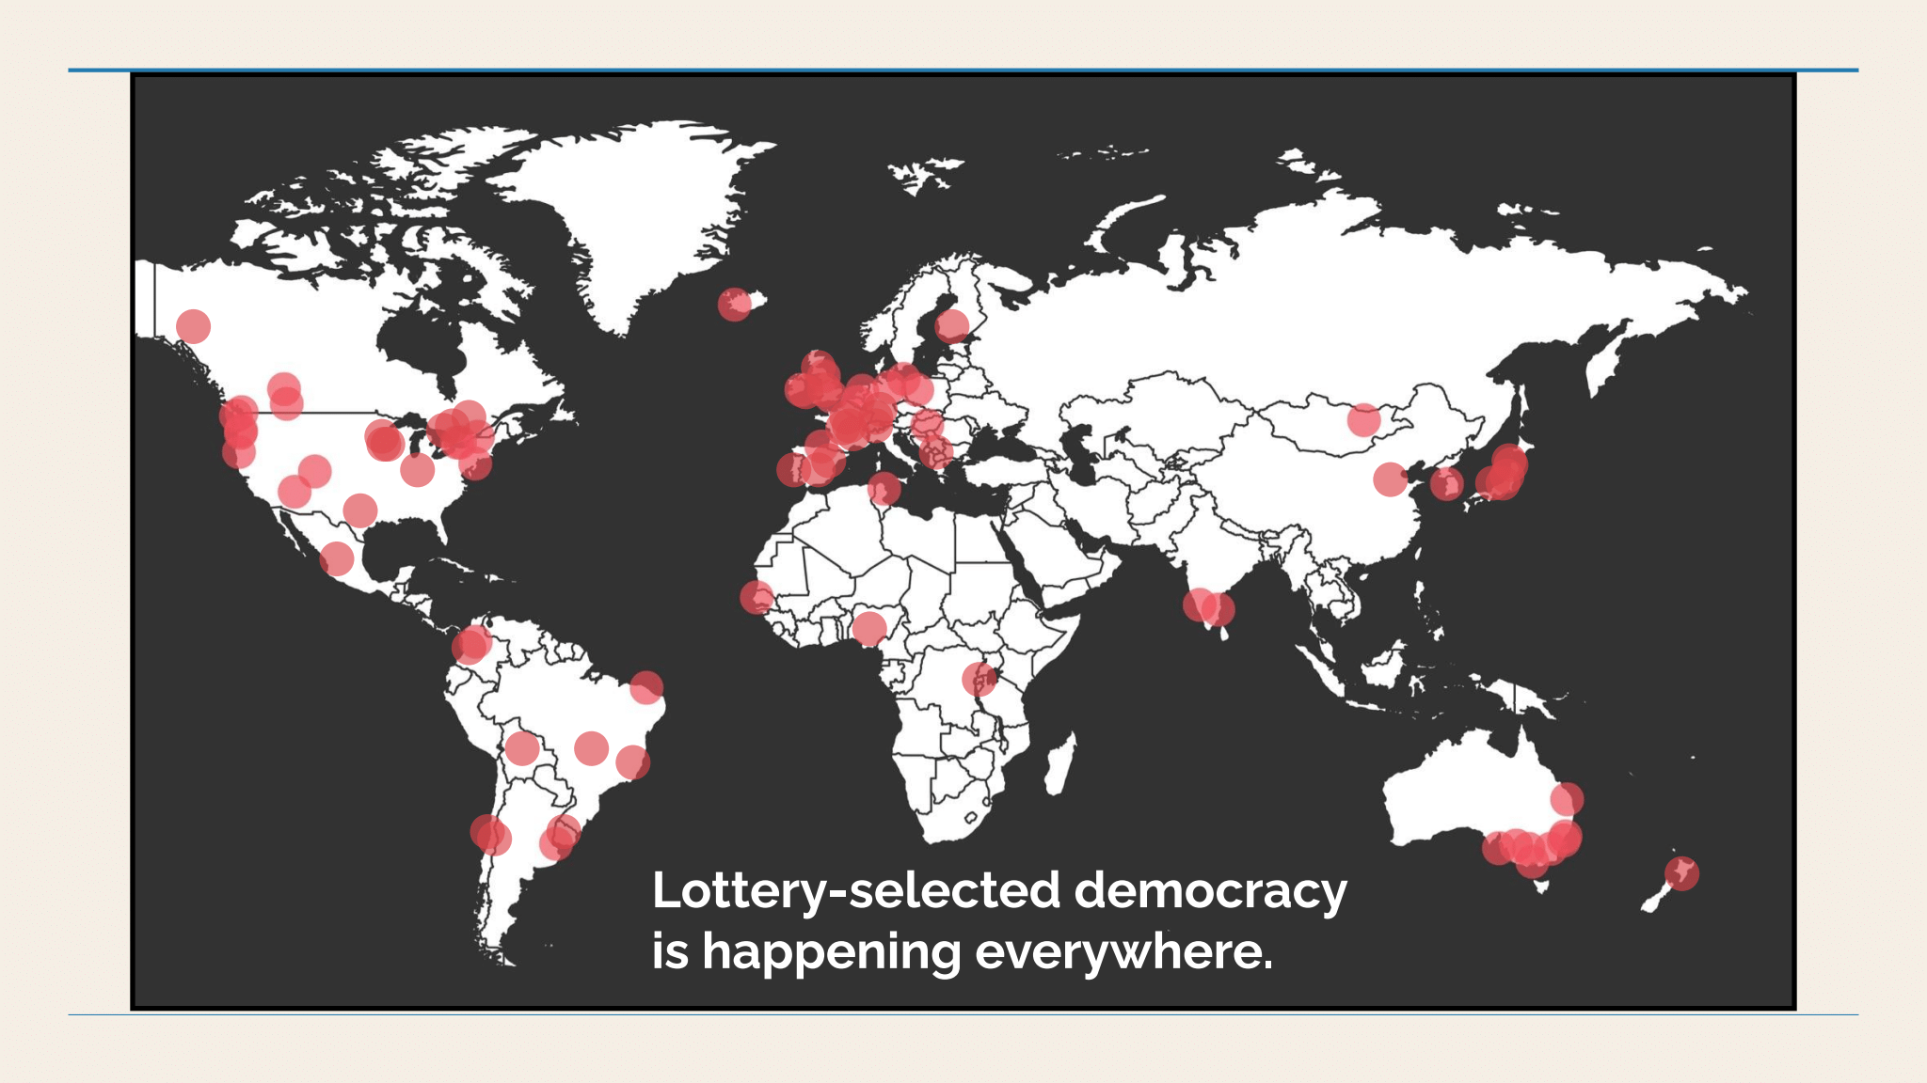

**Some examples of Citizen Assemblies have been working well:**

Glen added that a good number of years ago, the big city of Porto Alegre, Brazil, started a profoundly democratic process to develop its municipal budget. The citizens like that.

Nick said there are similarities between this kind of city budgeting process and Citizens’ Assemblies. He said Citizens’ Assemblies have much broader powers to recommend laws, rather than be limited to budget development. He said these kinds of panels have addressed a wide range of public policy areas, especially urban planning, strategic planning, and environment, but also many other issues, including health, infrastructure, civic engagement, public services, families, transportation, technology, energy, and more:

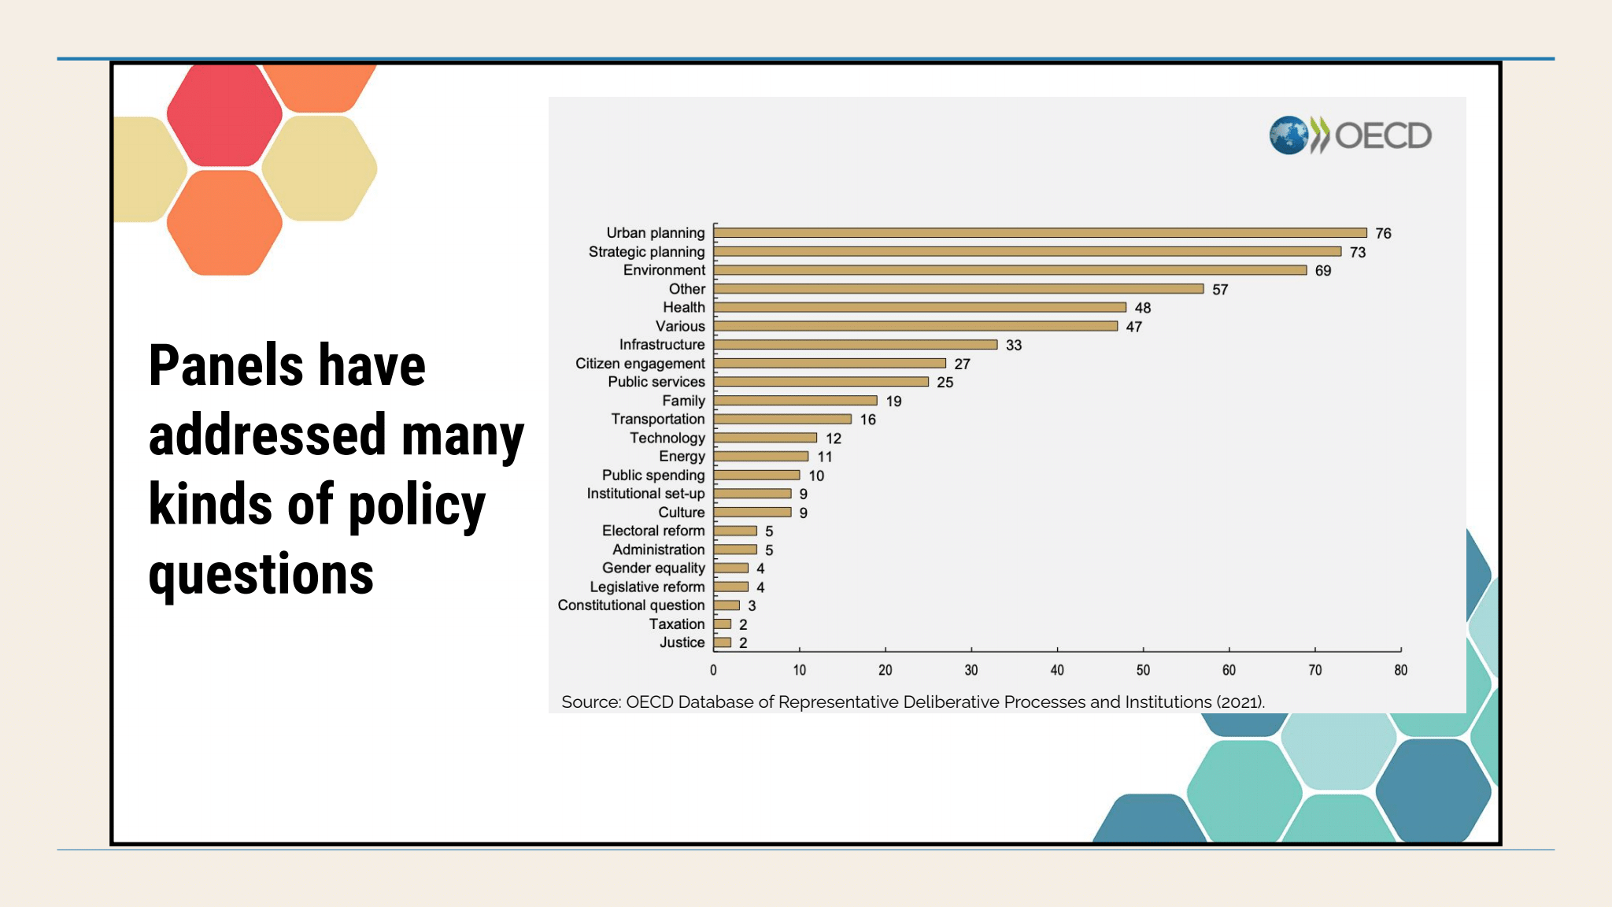

Nick showed this image and said that the American people really do like the idea of using these kinds of processes for ordinary people to shape public policies in the U.S. Nearly 4/5 of Americans want this to shape our national public policies. A survey showed 43% said it is very important and another 36% said somewhat important:

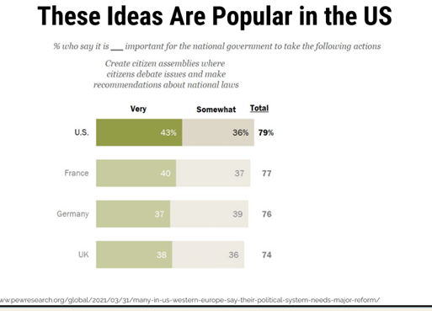

Nick also said that public opinion polling shows people would like to participate in these activities, contribute their knowledge and skills, and have governments listen to their recommendations.

He mentioned a few case studies that could encourage us to proceed. Here are just a few of a growing number of examples of successes:

He said the Republic of Ireland has used this process very well at the national level for more than a decade, and it has received positive attention for it. In 2012, 2/3 of the participants were ordinary citizens from all walks of life, and in 2016 all of the participants were ordinary folks. They proposed progressive public policies, and their process was validated when a referendum achieved 66% approval for legalizing abortion after 64% of the Citizens’ Assembly had recommended legalizing it:

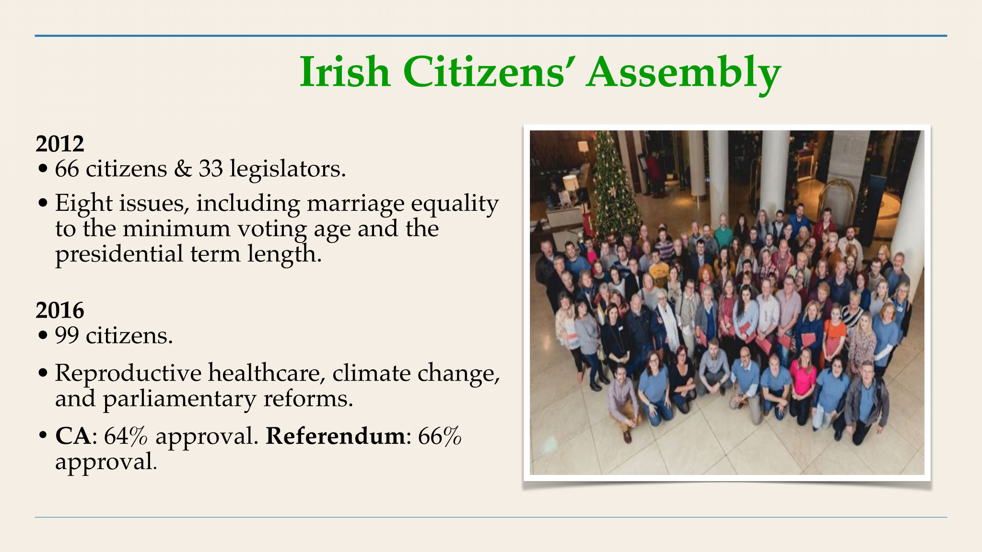

Recently Eugene, Oregon, used this kind of process to appoint 29 randomly selected residents aged 16+ to study some changes to housing codes. This was a very contentious issue. They met online because of the pandemic. They issued four reports that did influence the city’s decisions.

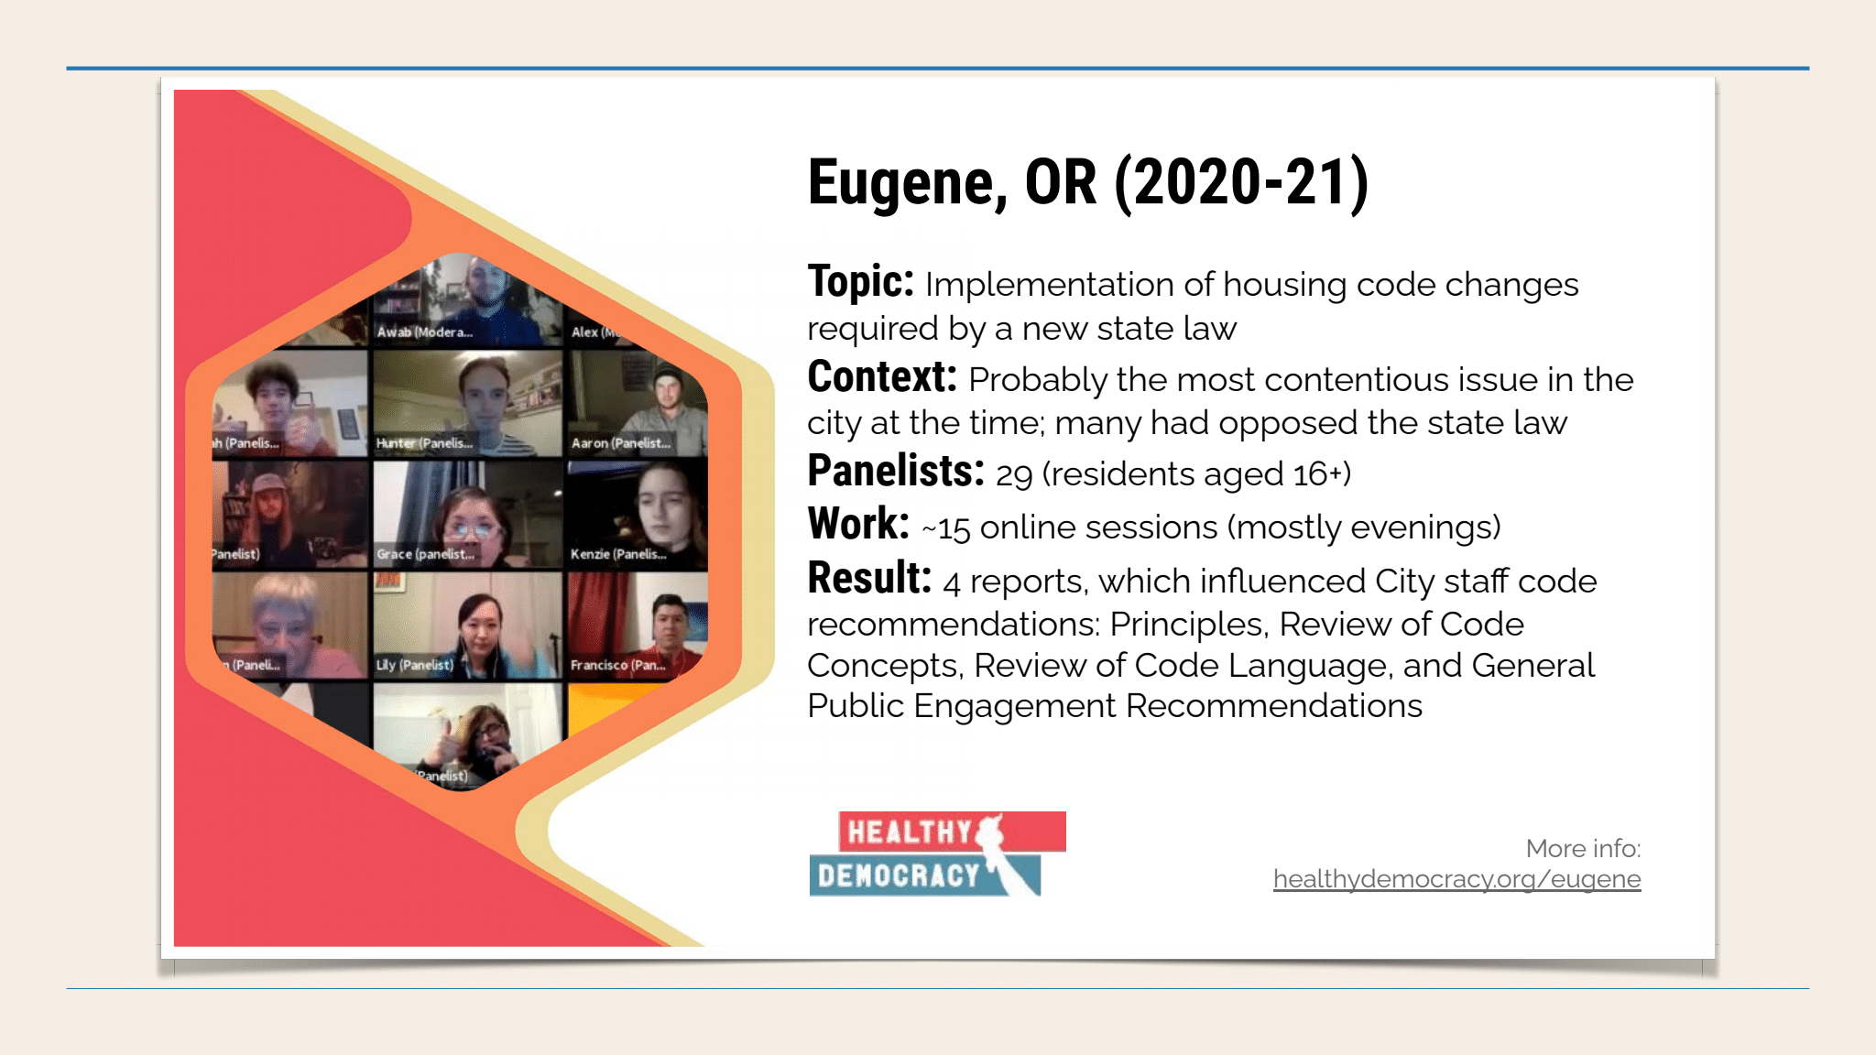

Nick said that during the 2020 election, an “America in One Room” event occurred in Texas. An independent organization funded it, used a democratic lottery to choose 525 ordinary citizens to gather and hear experts’ information about hot issues (health care reform, immigration, etc.) and to deliberate (with help from facilitators) and try to find common ground. This image shows that on 22 of the 47 issues the original polarization had decreased:



Nick showed on the screen this workable model:

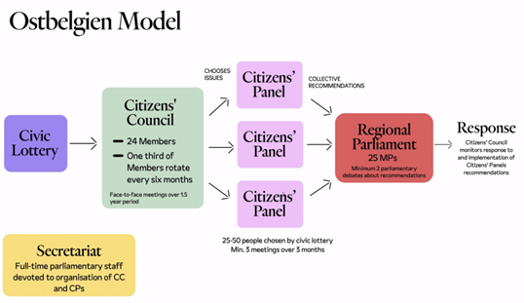

Nick quoted President Abraham Lincoln: “What I want is to get done what the people desire to have done, and the question for me is how to find that out exactly.”

Nick said now we can find out exactly what the people want. He urged moving to a new paradigm, as shown at the top of the next column. Move toward replacing elections with democracy by lottery, so people are chosen by lot to be citizen representatives. Move away from elected legislatures toward assemblies of ordinary citizens who can thoughtfully deliberate and make wise decisions. Move away from electoral polarizations and conflicts toward a collaborative model that can reach broad consensus and find common ground.

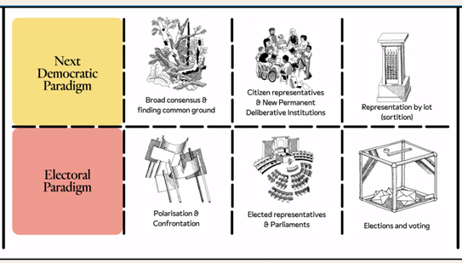

Glen has paid attention to Washington State legislative issues and activities. During the 2023 legislative session, some demographically diverse people were urging that they be consulted meaningfully about legislation that would affect them. Their slogan was “Nothing about us without us.”

Glen said that when we were preparing for this interview, Nick had expressed interest in applying this new model to other areas in our society. Glen also is interested in applying these principles to many sectors of our nation and our society. For example, if we had really profound democracy, what would our economy look like? And what would our foreign policy look like?

Nick’s proposals are better than our elections, but until we accomplish these bold reforms, Glen does want to clean up the various kinds of corruption and dysfunction in our current electoral system – even while we move ahead toward more profound democracy.

A number of years ago, a guest on one of Glen’s TV programs said only 5% of democracy is about voting, while. 95% of democracy is about grassroots organizing. Let’s make powerful changes from the grassroots up.

Glen said that whenever a great idea comes along – and people want to implement it – we always wonder, “How could we accomplish this? How could we get from here to there?” Unfortunately, we did not have time during this hour to strategize how to move forward toward implementation of this new paradigm. But Nick did show these ideas:

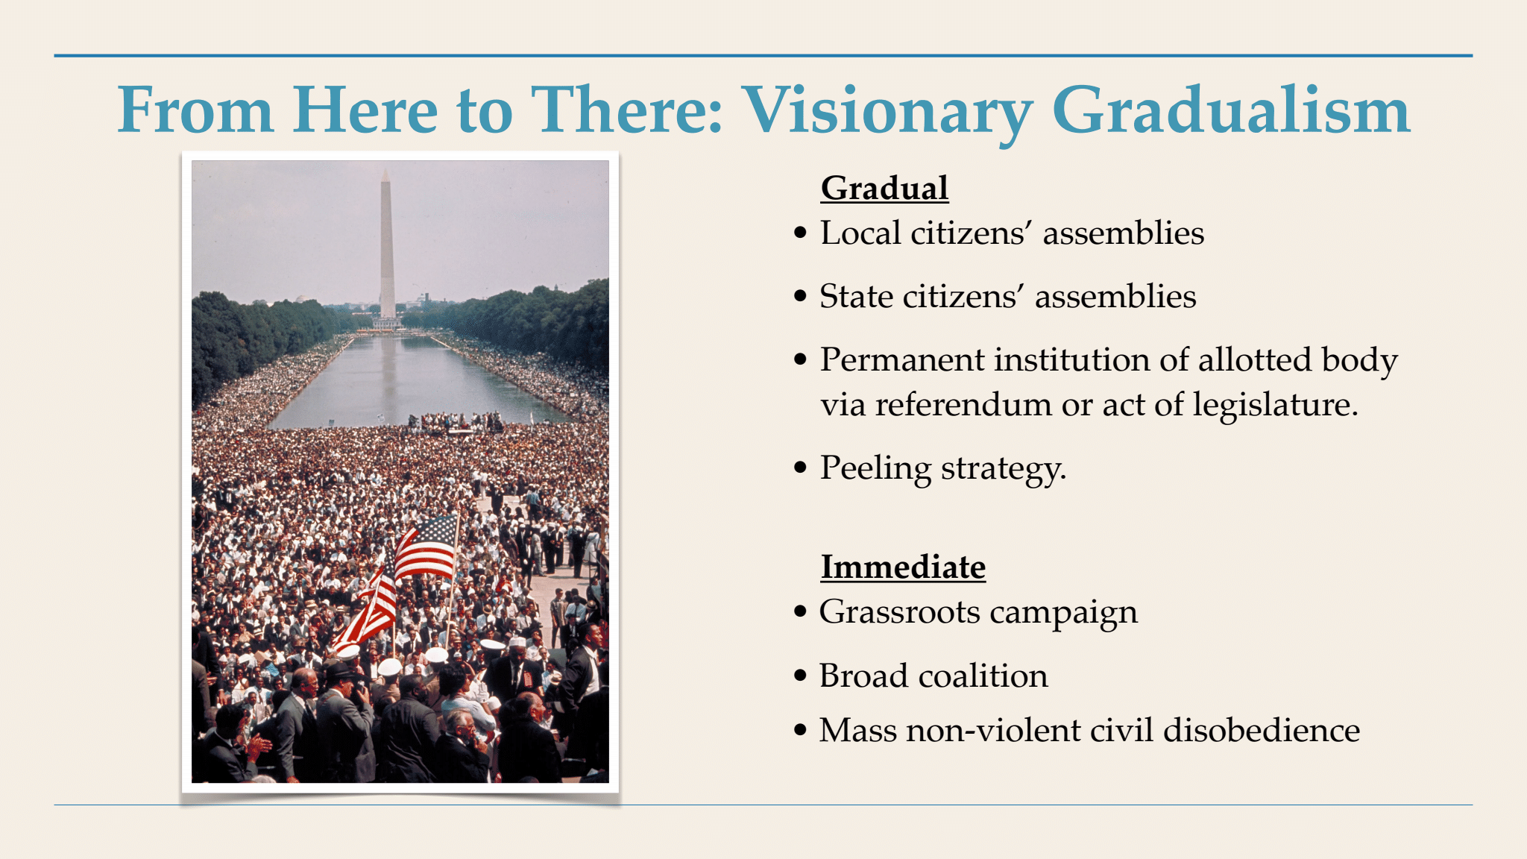

**See more information about this and related issues:**

Some of Glen’s previous TV programs have focused on issues related to our current topic. Examples:

* Glen’s May 2023 TV program makes a solid case for **adding the “We the People” amendment to the U.S. Constitution** in order to greatly strengthen democracy and promote fairness instead of domination by big business corporations. Watch the video and/or read my thorough article about what we said on TV at this link: [**https://parallaxperspectives.org/we-the-people-vs-corporate-rule-its-up-to-us-may-2023-tv-program-and-article-about-constitutional-amendment**](https://parallaxperspectives.org/we-the-people-vs-corporate-rule-its-up-to-us-may-2023-tv-program-and-article-about-constitutional-amendment)
* Glen’s May 2019 TV program explains how Ranked-Choice Voting could strengthen Democracy. Watch the video and/or read my thorough article about what we said on TV at this link: [**https://parallaxperspectives.org/tv-ranked-choice-voting-strengthens-democracy**](https://parallaxperspectives.org/tv-ranked-choice-voting-strengthens-democracy)
* Glen’s June 2022 TV program explains how **“Big Money” corrupts our elections and our government**. This program proposes ways to strengthen democracy instead. Watch the video and/or read my thorough article about what we said on TV about the topic at this link: [**https://parallaxperspectives.org/big-money-in-elections-corrupts-our-government**](https://parallaxperspectives.org/big-money-in-elections-corrupts-our-government)
* Glen’s March 2011 TV program urges us to **reject the “corporate personhood” doctrine**. Watch the video and/or read about the topic at this link: [**https://parallaxperspectives.org/tv-real-democracy-not-corporate-personhood**](https://parallaxperspectives.org/tv-real-democracy-not-corporate-personhood)

Glen invites people to visit his blog and see information at dozens of issue categories. This TV program is posted to the categories for “TV Programs,” and “Democracy,” and “Political Parties and Elections.” The blog is at [**www.parallaxperspectives.org**](http://www.parallaxperspectives.org)

**Nick’s bold new proposal is not well known, so he provided these sources of information to help us learn more about it:**

Nick’s Substack series is at [**https://nickcoccoma.substack.com/**](https://nickcoccoma.substack.com/)

Tom Atlee’s book is at [**https://empoweringpublicwisdom.us/**](https://empoweringpublicwisdom.us/)

**Democracy by Lottery Resources:**

**Videos:**

* [Top Ten Videos](https://www.bretthennig.com/ten_best_sortition_videos)
* [The Economist](https://www.youtube.com/watch?app=desktop&v=6UcFQ-eDhTk&ab_channel=TheEconomist&fbclid=IwAR350E1nGThUtHNBi4v3XHR-96R2NnHlsOrUHbieP1AqQwKOeqLcval8Zsc)
* [Fast Company](https://www.fastcompany.com/video/would-lotteries-improve-democracy/dPvvlyrB?fbclid=IwAR3dZJPi1fCcK2kgztyCxCw1HqRo3avTPkbkdChEJ1fk6I1hI9QxHg2EOs4)
* [The Kleroterion](https://www.youtube.com/watch?v=gt9H7nbZjAw)

**Podcasts:**

* “[Terry Bouricius on Democracy](https://nickcoccoma.substack.com/p/terry-bouricius-on-democracy#details),” The Similitude
* “[Democracy Without Politicians,](https://www.howtocitizen.com/episodes/democracy-without-politicians-claudia-chwalisz)” How To Citizen
* [Real Democracy Now!](https://realdemocracynow.com.au/podcast/podcasts/season-1-deliberative-mini-publics/)
* [The Ezra Klein Show](https://www.nytimes.com/2021/02/23/opinion/ezra-klein-podcast-helene-landemore.html?action=click&module=Opinion&pgtype=Homepage&fbclid=IwAR1hOuFAjRxA2xGZZfdEFJmFEbgx4JOmLgA1mEajVoMsiBZlUtZ3gZOKJEo)
* [Forward Together](https://share.transistor.fm/s/152735df?fbclid=IwAR0bcj9ziVf1BFlBOwCU4qSB5aGBTp0heEXd51ibLjGqZ_Ekdv2-9jfFhXU)

**Blogs:**

* [Equality by Lot](https://equalitybylot.com/)
* [Jury Democracy](https://alexkovner.com/)
* [Democracy by Lottery](https://demlotteries.substack.com/)

**Articles:**

* [Boston Review](https://www.bostonreview.net/articles/the-case-for-abolishing-elections/)
* [The New Yorker](https://www.newyorker.com/news/the-future-of-democracy/politics-without-politicians)
* [Politico](https://www.politico.eu/article/belgium-democratic-experiment-citizens-assembly/)
* [Vox](https://www.vox.com/future-perfect/22878118/jury-duty-citizens-assembly-lottocracy-open-democracy)
* [In These Times](https://inthesetimes.com/article/direct-democracy-sortition-populism-voting-citizens-assembly?fbclid=IwAR1CjoJeEGYql-xBbupUpICgnO7OUsZhu-y5crzMOeqoJ6Gexk4vVV70to4)
* [Foreign Policy](https://foreignpolicy.com/2021/12/07/biden-democracy-summit-people-power/?fbclid=IwAR2BO0CpSEPEjzyPvfo19FRmaYOVNCL20MNfw628zSBn0ViaAeWihULeguA)
* [The Harvard Gazette](https://news.harvard.edu/gazette/story/2021/05/jane-mansbridge-offers-a-solution-to-mending-a-riven-democracy/?fbclid=IwAR1GSN1j3h-YxvuFj5h3x6VU4407Y-X6_xD3kY2TTrNccDtW-lJPjBOp5QE)
* [The Financial Times](https://www.ft.com/content/db7407ba-c6a4-4896-b617-fb4738475de0?fbclid=IwAR2tjn6g_g3JMu2qlqbE4xhtGbdKp-2lQTQFIyUXQ_jLlWek1pbcrZkLFKM)
* [Fast Company](https://www.fastcompany.com/90606492/what-if-we-replaced-elected-politicians-with-randomly-selected-citizens?fbclid=IwAR32wWnJ1i84DbxoRGI64uQdj2HL0v_8nPSalLeovgrV1Aopo4TvGpJeWZs)
* [New Internationalist](https://newint.org/features/2021/02/08/defibrillating-democracy?fbclid=IwAR3f6BhtmPMwCuQ01HrZncpMXsVdPDl4NzJVK30Xp8ChcbqKAnS0peXfKV8)
* [The Brookings Institute](https://www.realclearpolicy.com/articles/2021/06/08/the_wisdom_of_small_crowds_the_case_for_using_citizens_juries_to_shape_policy_780429.html?fbclid=IwAR32wWnJ1i84DbxoRGI64uQdj2HL0v_8nPSalLeovgrV1Aopo4TvGpJeWZs)

**Organizations:**

* [DemocracyNext](https://demnext.org/)
* [of by for*](https://joinofbyfor.org/)
* [Democracy Without Elections](https://democracywithoutelections.org/)
* [Healthy Democracy](https://healthydemocracy.org/)
* [Democracy R&D](https://democracyrd.org/)
* [The Sortition Foundation](https://www.sortitionfoundation.org/)
* [The Center for New Democratic Processes](https://www.cndp.us/)
* [MASS LBP](https://www.masslbp.com/)
* [The Irish Citizens’ Assembly](http://citizenassembly.ie/home/)
* [g1000](http://www.g1000.org/)
* [newDemocracy](https://www.newdemocracy.com.au/)
* [Global Assembly](https://www.globalassembly.org/?fbclid=IwAR1CjoJeEGYql-xBbupUpICgnO7OUsZhu-y5crzMOeqoJ6Gexk4vVV70to4)
* [National Coalition for Dialogue and Deliberation](https://www.ncdd.org/)

**Four Categories of Books:**

**General:**

* [The Keys to Democracy: Sortition as a New Model for Citizen Power](http://books.imprint.co.uk/book/?gcoi=71157100410200) (2023) by Maurice Pope
* [The Government of Chance: Sortition and Democracy from Athens to the Present](https://www.amazon.com/gp/product/1009285637/ref=ox_sc_saved_image_2?smid=ATVPDKIKX0DER&psc=1) (2023) by Yves Sintomer
* [Against Elections: The Case for Democracy](https://www.amazon.com/Against-Elections-David-Van-Reybrouck/dp/1847924220) (2018) by David Van Reybrouck
* [Democracy: A Life](https://www.amazon.com/Democracy-Life-Paul-Cartledge/dp/0199837457/ref=tmm_hrd_swatch_0?_encoding=UTF8&qid=&sr=) (2018) by Paul Cartledge
* [The End of Politicians: Time for a Real Democracy](https://www.amazon.com/End-Politicians-Time-Real-Democracy/dp/1911586106/ref=tmm_pap_swatch_0?_encoding=UTF8&qid=1643729749&sr=1-1) (2017) by Brett Hennig

**Theory:**

* [Demopolis: Democracy Before Liberalism in Theory and Practice](https://www.amazon.com/Demopolis-Democracy-Liberalism-Practice-Lectures-ebook/dp/B072ZTNK4K?ref_=ast_author_dp) (2017) by Josiah Ober
* [Open Democracy: Reinventing Popular Rule for the Twenty-First Century](https://www.amazon.com/gp/product/0691181993/ref=ox_sc_saved_title_1?smid=ATVPDKIKX0DER&psc=1) (2020) by Helene Landemore
* [Democratic Reason: Politics, Collective Intelligence, and the Rule of the Many](https://www.amazon.com/gp/product/0691176396/ref=ox_sc_saved_title_8?smid=ATVPDKIKX0DER&psc=1) (2017) by Helene Landemore
* [Sortition and Democracy: History, Tools, Theories](https://www.amazon.com/gp/product/1788360168/ref=ox_sc_saved_title_4?smid=A1JKVWH22E85VP&psc=1) (2020) ed. Liliane Lopez-Rabatel and Yves Sintomer
* [Foundations and Frontiers of Deliberative Governance](https://www.amazon.com/gp/product/0199644853/ref=ox_sc_saved_title_3?smid=ATVPDKIKX0DER&psc=1) (2012) by John Dryzek

**Athenian Democracy:**

* [Athenian Democracy in the Age of Demosthenes: Structure, Principles, and Ideology](https://www.amazon.com/Athenian-Democracy-Age-Demosthenes-Principles/dp/0806131438/ref=sr_1_1?crid=9FN7D3MXH3TE&keywords=athenian+democracy+in+the+age+of+demosthenes&qid=1678472097&sprefix=athenian+democracy+in+the+age+of+demosthenes%2Caps%2C81&sr=8-1) (1999) by Mogens Herman Hansen
* [The Rise and Fall of Classical Greece](https://www.amazon.com/Classical-Greece-Princeton-History-Ancient/dp/0691173141/ref=sr_1_1?crid=1VREOYUA2GHQ&keywords=the+rise+and+fall+of+classical+greece&qid=1676841219&sprefix=the+rise+and+fall+of+classical+%2Caps%2C91&sr=8-1) (2016) by Josiah Ober
* [Democracy and Knowledge: Innovation and Learning in Classical Athens](https://www.amazon.com/Democracy-Knowledge-Innovation-Learning-Classical/dp/0691146241/?_encoding=UTF8&pd_rd_w=q8g1k&content-id=amzn1.sym.22f5776b-4878-4918-9222-7bb79ff649f4&pf_rd_p=22f5776b-4878-4918-9222-7bb79ff649f4&pf_rd_r=145-5094603-5620543&pd_rd_wg=BKUei&pd_rd_r=403ff108-7a71-4233-9c79-6574c41505fc&ref_=aufs_ap_sc_dsk) (2010) by Josiah Ober
* [Athenian Legacies: Essays on the Politics of Going On Together](https://www.amazon.com/Athenian-Legacies-Essays-Politics-Together/dp/0691133948/ref=tmm_pap_swatch_0?_encoding=UTF8&qid=&sr=) (2007) by Josiah Ober
* [The Athenian Revolution: Essays on Ancient Greek Democracy and Political Theory](https://www.amazon.com/Athenian-Revolution-Josiah-Ober/dp/0691001901/ref=tmm_pap_swatch_0?_encoding=UTF8&qid=&sr=) (1998) by Josiah Ober
* [Mass and Elite in Democratic Athens: Rhetoric, Ideology, and the Power of the People](https://www.amazon.com/Mass-Elite-Democratic-Athens-Rhetoric/dp/0691028648/?_encoding=UTF8&pd_rd_w=q8g1k&content-id=amzn1.sym.22f5776b-4878-4918-9222-7bb79ff649f4&pf_rd_p=22f5776b-4878-4918-9222-7bb79ff649f4&pf_rd_r=145-5094603-5620543&pd_rd_wg=BKUei&pd_rd_r=403ff108-7a71-4233-9c79-6574c41505fc&ref_=aufs_ap_sc_dsk) (1991) by Josiah Ober
* [Origins of Democracy in Ancient Greece](https://www.amazon.com/Origins-Democracy-Ancient-Greece-Raaflaub-ebook/dp/B003DQP80A?ref_=ast_author_dphttps://www.amazon.com/Origins-Democracy-Ancient-Greece-Raaflaub-ebook/dp/B003DQP80A?ref_=ast_author_dp) (2008) ed. Josiah Ober
* [Demokratia: A Conversation on Democracies, Ancient and Modern](https://www.amazon.com/Demokratia-Josiah-Ober/dp/0691011087/ref=tmm_pap_swatch_0?_encoding=UTF8&qid=&sr=) (1996) ed. Josiah Ober
* [Athenian Political Thought and the Reconstitution of American Democracy](https://www.amazon.com/Athenian-Political-Reconstitution-American-Democracy/dp/0801481791/ref=tmm_pap_swatch_0?_encoding=UTF8&qid=&sr=) (1994) ed. Josiah Ober

**Contemporary Designs:**

* “[Democracy Through Multi-Body Sortition: Athenian Lessons for the Modern Day](https://delibdemjournal.org/article/id/428/),” (2013) by Terrill Bouricius, The Journal of Deliberative Democracy
* [Legislature by Lot: Transformative Designs for Deliberative Governance](https://www.versobooks.com/books/2969-legislature-by-lot) (2019) ed. John Gastil and Erik Olin Wright
* [Democracy in Crisis: Lessons from Ancient Athens](https://www.amazon.com/gp/product/178836063X/ref=ox_sc_saved_title_2?smid=ATVPDKIKX0DER&psc=1) (2022) by Jeff Miller
* [Rebooting Democracy: A Citizen’s Guide to Reinventing Politics](https://www.amazon.com/Rebooting-Democracy-Citizens-Reinventing-Politics/dp/0692224874/ref=tmm_pap_swatch_0?_encoding=UTF8&qid=1678471650&sr=8-1-fkmr0) (2014) by Manuel Arriaga
* [The Political Potential of Sortition: A study of the random selection of citizens for public office](https://www.amazon.com/gp/product/1845401794/ref=ox_sc_saved_title_7?smid=A1JKVWH22E85VP&psc=1) (2009) by Oliver Dowlen
* [A People's Parliament/A Citizen Legislature](https://www.amazon.com/gp/product/1845401085/ref=ox_sc_saved_title_5?smid=A1QJ4UH6FW3UH1&psc=1) (2008) by Keith Sunderland
* [Saving Democracy: A Plan for Real Representation in America](https://www.amazon.com/gp/product/0804754985/ref=ox_sc_saved_title_10?smid=A16ET7DS3ZNK1W&psc=1) (2006) by Kevin O’Leary
* [Deliberative Democracy in America: A Proposal for a Popular Branch of Government](https://www.amazon.com/gp/product/0271026979/ref=ox_sc_saved_title_9?smid=A3V2S9N0VSBJZF&psc=1) (2004) by Ethan Leib
* [A Citizens’ Legislature](https://people.well.com/user/mp/citleg.html) (1985) by Ernest Callenbach and Michael Phillips: <https://people.well.com/user/mp/citleg.html>

**Glen’s closing encouragement:**

Glen thanked Nick Coccoma for sharing his information and insights with us. He also thanked the people who have been watching this TV program.

He said he designs his TV series to help people understand problems – and create bold solutions!

The American people want better democracy, but they are frustrated that our current system falls so far short. People want better solutions. He said he hopes people will consider what Nick Coccoma and some other people are proposing. It is very different from the status quo, so this challenges us to be bold and creative in moving ahead.

Nick showed this quotation on the screen:

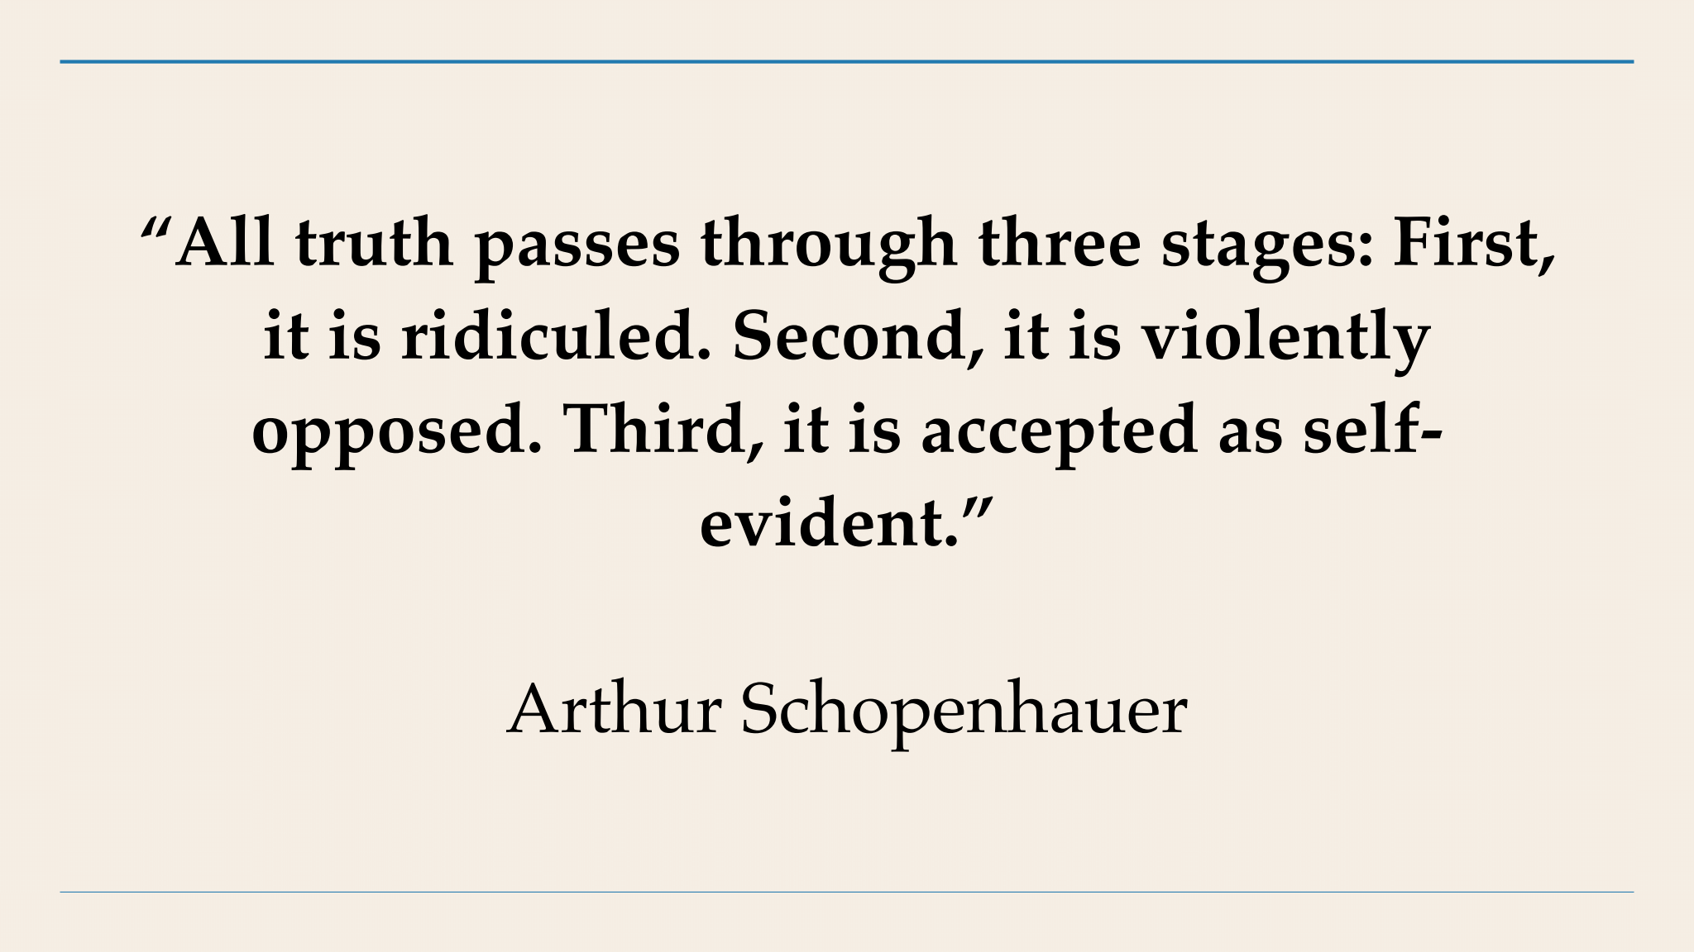

Glen said he likes what Buckminster Fuller said: “You never change things by fighting the existing reality. To change something, build a new model that makes the existing model obsolete.” Let’s be creative to achieve truly profound democracy!

Glen said that today’s topic shows us that reforming our current electoral system – while necessary – is not enough. A very bold new system of lotteries and citizens’ assemblies can make our current dysfunctional politics obsolete and create a profound democracy.

He said that years ago one of his TV guests had said that only about 5% of democracy is about voting, while 95% of democracy is about grassroots organizing. Glen likes that insight!

Democracy is intrinsically best for human beings, because only through democracy can we freely exercise our innate capacities and flourish. Real democracy would make us happy!

Glen encouraged TV viewers to tell your friends about this TV program and encourage them to watch it on TV during June 2023 in Thurston County, Washington. It airs on Thurston Community Media’s cable channel 22 three times a week for the full month: every Monday at 1:30 pm, every Wednesday at 5:00 pm, and every Thursday at 9:00 pm.

Also, your friends can watch this TV video and read what we said by visiting Glen’s blog from anywhere at any time. The blog is at [**www.parallaxperspectives.org**](http://www.parallaxperspectives.org). Parallax has ONE R and TWO L’s. Pa-Ra-LL-AX Perspectives.org. Visit the blog, click the link for **“TV Programs,”** and click the link for this episode, titled, **“Using Lotteries to Create an Open Democracy.”**

You can get information about a wide variety of issues related to peace, social justice and nonviolence through my blog, [**www.parallaxperspectives.org**](http://www.parallaxperspectives.org)or by phoning me at   
(360) 491-9093 or e-mailing me at [**glen@parallaxperspectives.org**](mailto:glen@parallaxperspectives.org)

I end each TV program with this invitation to help make progress:

**We're all one human family, and we all share one planet.**

**We can create a better world, but we all have to work at it.**

**The world needs whatever you can do to help!**